

# **ADBMS LAB FILE**

**Submitted by: Submitted to:**

**NAME : Rahul Gusain Dr.Ankit Khare**

**SAP : 500084143**

**ROLL NO. : R214220900**

**BATCH : 1 DevOps**

| **Sno.** | **Experiment Name** |
| --- | --- |
| **1** | **To understand DDL and DML commands** |
| **2** | **To understand and apply the concept of Constraints.** |
| **3** | **To understand and use SQL Sub-Query** |
| **4** | **Use of Inbuilt functions and relational algebra operation** |
| **5** | **Use of different SQL clauses and join Objective: To understand the use of group by and having clause and execute the SQL commands using JOIN** |
| **6** | **Students will be able to implement the concept of views.** |
| **7** | **To understand the concepts of Index.** |
| **8** | **To understand the concepts of Sequence** |
| **9** | **To understand the concepts of PL/SQL programming.** |
| **10** | **To understand the concepts of function and procedure in PL/SQL.** |

**LAB 1**

**EXPERIMENT-1**

**Title: To understand DDL and DML commands**

**Objective:** To understand the concept of designing issue related to the database with creating, populating the tables. Also familiarize students with different ways of manipulation in database.

1. **Create the tables described below:**

**Table name: CLIENT_MASTER Description:** used to store client information.

| **Column name** | **data type** | **Size** |
| --- | --- | --- |
| CLIENTNO | Varchar | 6 |
| NAME | Varchar | 20 |
| ADDRESS 1 | Varchar | 30 |
| ADDRESS 2 | Varchar | 30 |
| CITY | Varchar | 15 |
| PINCODE | Integer |  |
| STATE | Varchar | 15 |
| BALDUE | Decimal | 10,2 |

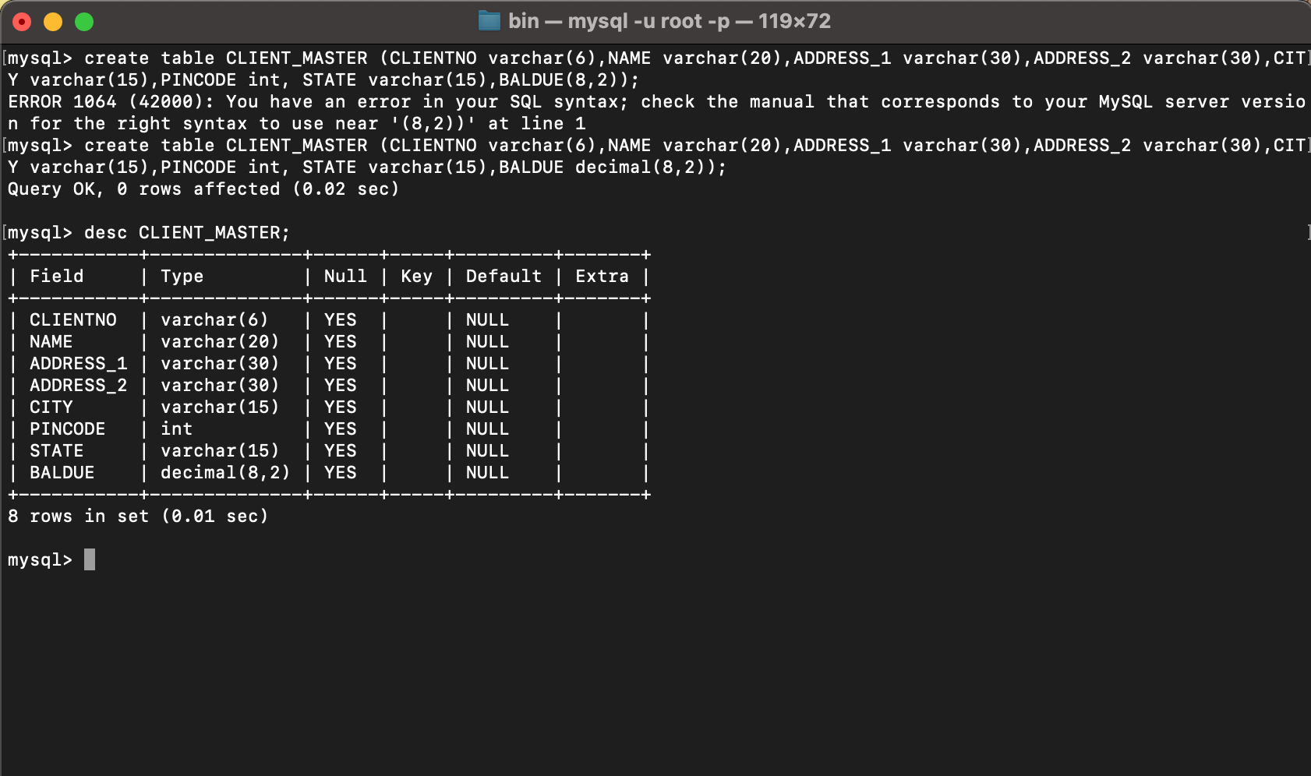

**Table Name: PRODUCT_MASTER Description:** used to store product information

| **Column name** | **data type** | **Size** |
| --- | --- | --- |
| PRODUCTNO | Varchar | 6 |
| DESCRIPTION | Varchar | 15 |
| PROFITPERCENT | Decimal | 4,2 |
| UNIT MEASURE | Varchar | 10 |
| QTYONHAND | Integer |  |
| REORDERL VL | Integer |  |
| SELLPRICE | Decimal | 8,2 |
| COSTPRICE | Decimal | 8,2 |

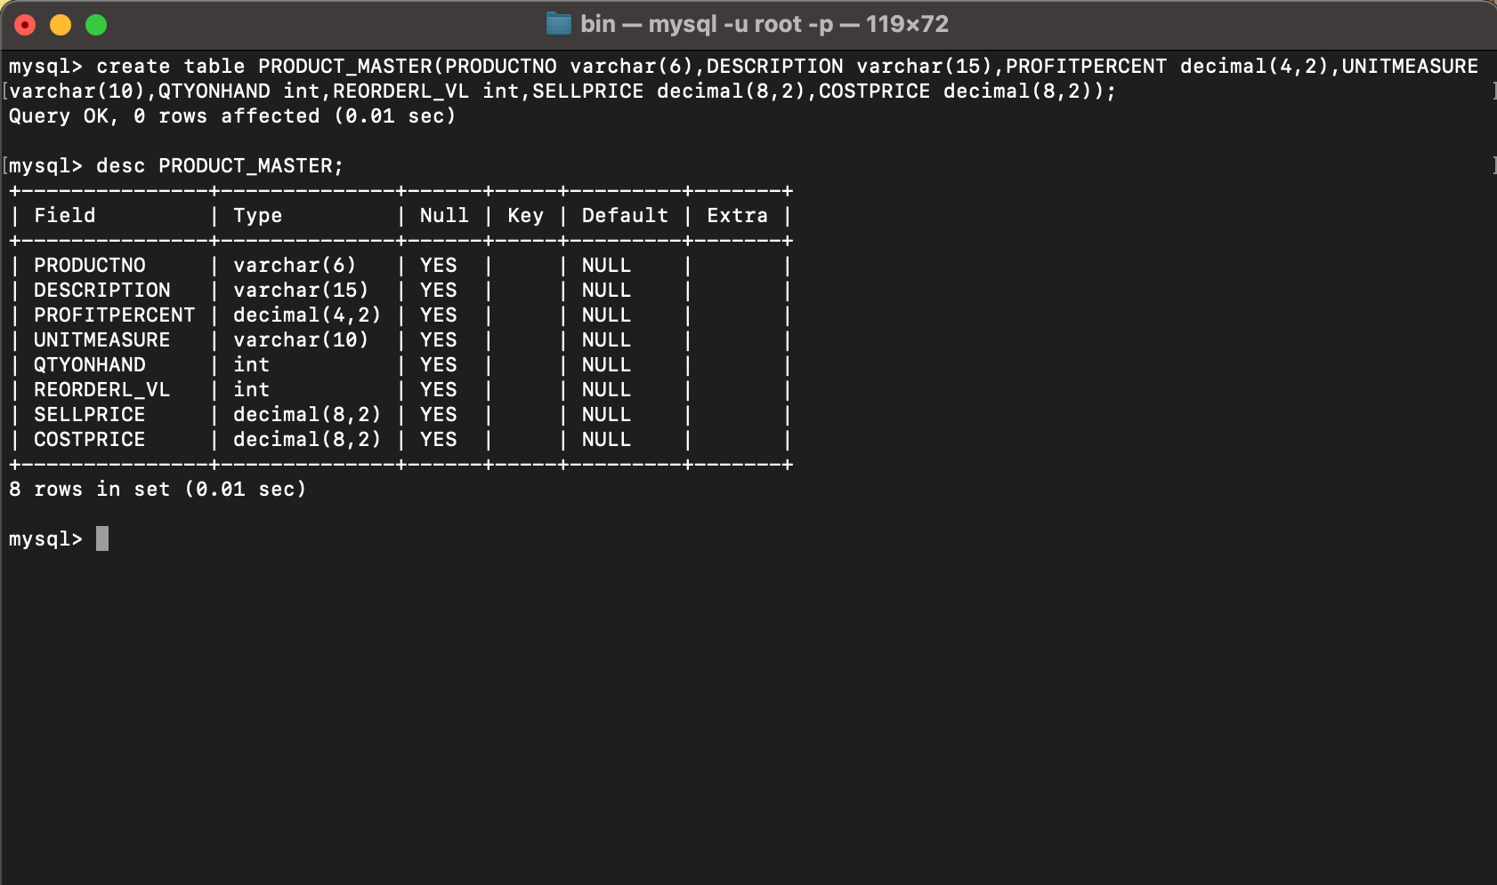

**Table Name: SALESMAN_MASTER**

**Description:** Used to store salesman information working for the company.

| **Column name** | **data type** | **Size** |
| --- | --- | --- |
| SALESMANNO | Varchar | 6 |
| SALESMANNAME | Varchar | 20 |
| ADDRESS 1 | Varchar | 30 |
| ADDRESS 2 | Varchar | 30 |
| CITY | Varchar | 20 |
| PINCODE | Integer |  |
| STATE | Varchar | 20 |
| SALAMT | Real |  |
| TGTTOGET | Decimal |  |
| YTDSALES | Double | 6,2 |
| REMARKS | Varchar | 60 |

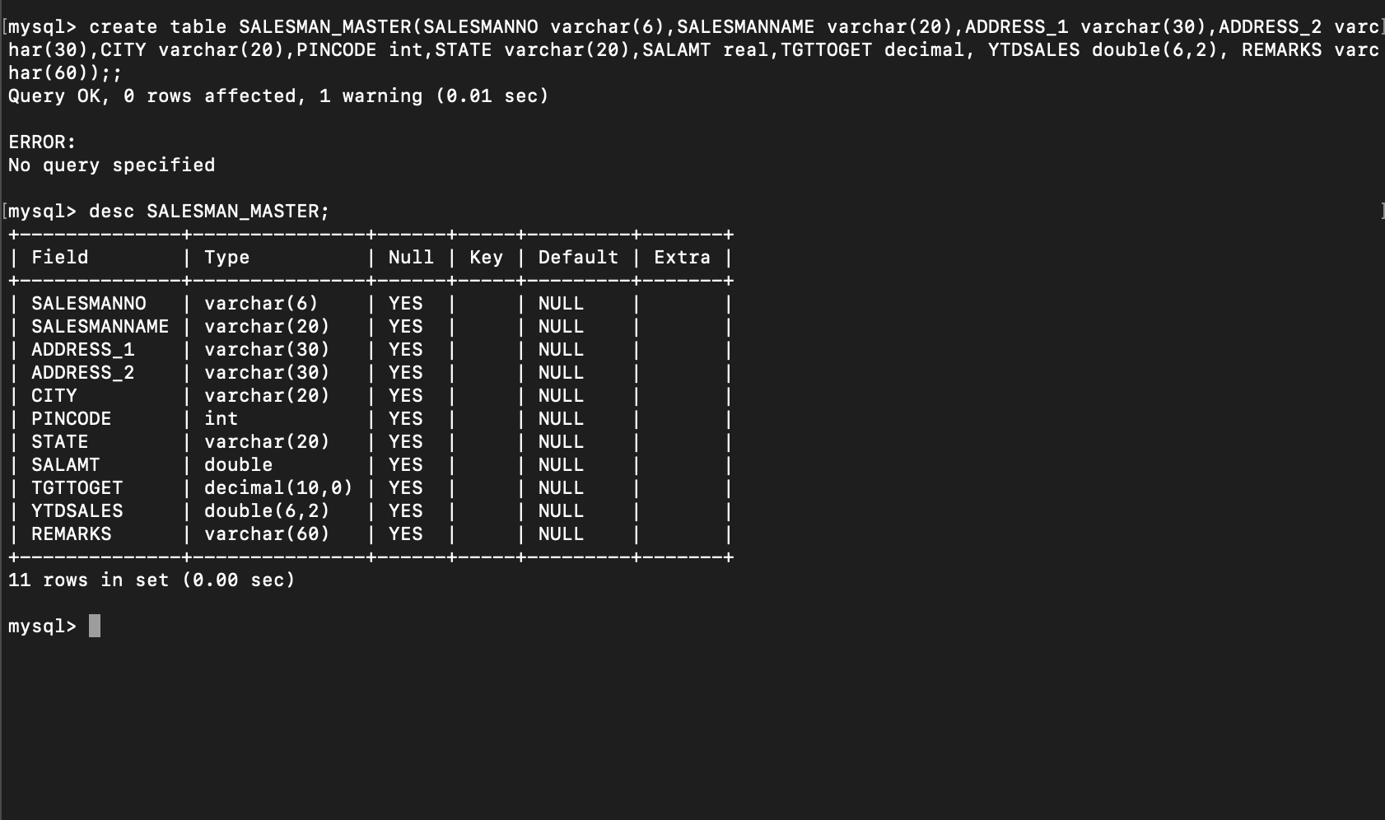

1. **Insert the following data into their respective tables:**
2. Data for **CLIENT_MASTER** table:

| Client no | Name | City | Pincode | State | BalDue |
| --- | --- | --- | --- | --- | --- |
| C00001 | Ivan bayross | Mumbai | 400054 | Maharashtra | 15000 |
| C00002 | Mamta muzumdar | Madras | 780001 | Tamil nadu | 0 |
| C00003 | Chhaya bankar | Mumbai | 400057 | Maharashtra | 5000 |
| C00004 | Ashwini joshi | Bangalore | 560001 | Karnataka | 0 |
| C00005 | Hansel colaco | Mumbai | 400060 | Maharashtra | 2000 |
| C00006 | Deepak sharma | Mangalore | 560050 | Karnataka | 0 |

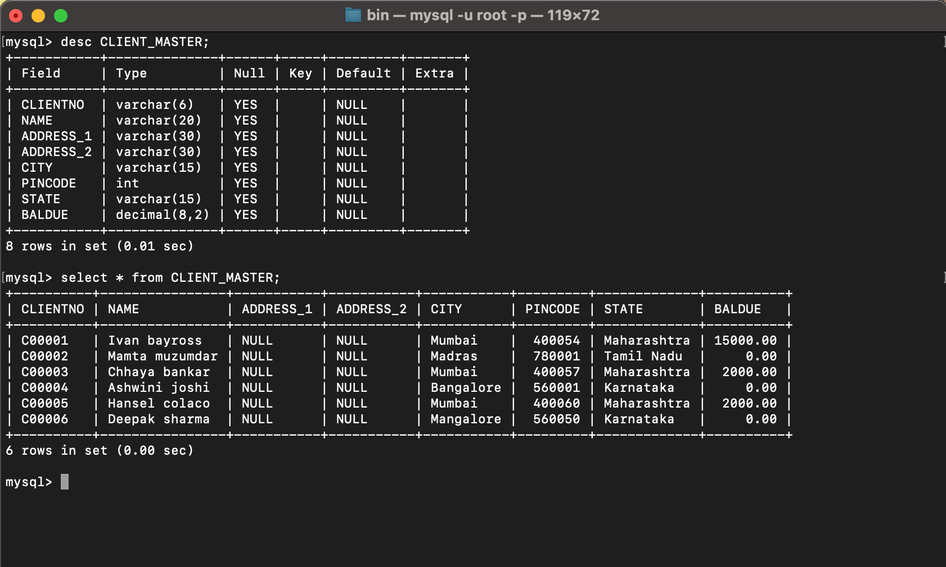

1. Data for **PRODUCT**_**MASTER** table:

| Product  No | Description | Profit percent | Unit measure | Quantity  On  hand | Recorder  Level | Sell  Price | Cost  Price |
| --- | --- | --- | --- | --- | --- | --- | --- |
| P00001 | T-Shirt | 5 | Piece | 200 | 50 | 350 | 250 |
| P0345 | Shirts | 6 | Piece | 150 | 50 | 500 | 350 |
| P06734 | Cotton jeans | 5 | Piece | 100 | 20 | 600 | 450 |
| P07865 | Jeans | 5 | Piece | 100 | 20 | 750 | 500 |
| P07868 | Trousers | 2 | Piece | 150 | 50 | 850 | 550 |
| P07885 | Pull Overs | 2.5 | Piece | 80 | 30 | 700 | 450 |
| P07965 | Denim jeans | 4 | Piece | 100 | 40 | 350 | 250 |
| P07975 | Lycra tops | 5 | Piece | 70 | 30 | 300 | 175 |
| P08865 | Skirts | 5 | Piece | 75 | 30 | 450 | 300 |

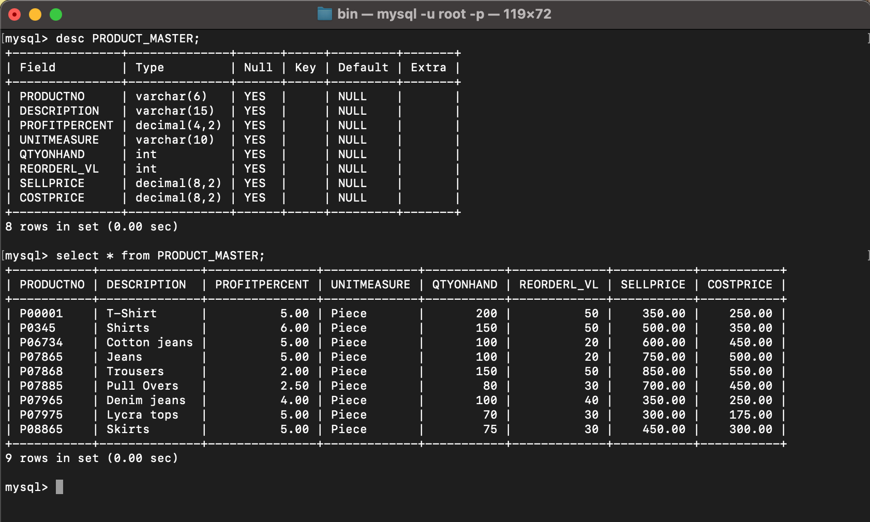

1. Data for **SALESMAN_MASTER**  table:

| **Salesman No** | **Name** | **Address1** | **Address2** | **City** | **Pin Code** | **State** |
| --- | --- | --- | --- | --- | --- | --- |
| S00001 | Aman | A/14 | Worli | Mumbai | 400002 | Maharashtra |
| S00002 | Omkar | 65 | Nariman | Mumbai | 400001 | Maharashtra |
| S00003 | Raj | P-7 | Bandra | Mumbai | 400032 | Maharashtra |
| S00004 | Ashish | A/5 | Juhu | Mumbai | 400044 | Maharashtra |

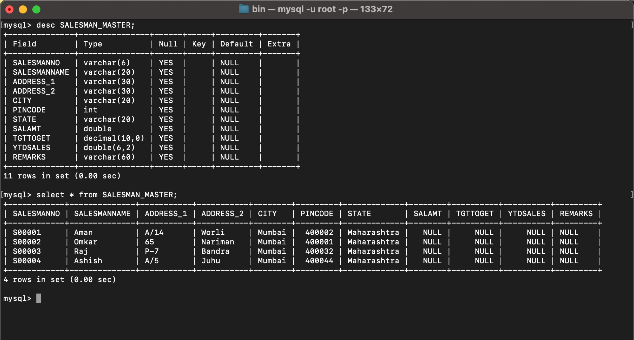

1. **Exercise on retrieving records from a table.**  
   a. Find out the names of all the clients.

**select name from CLIENT_MASTER;**

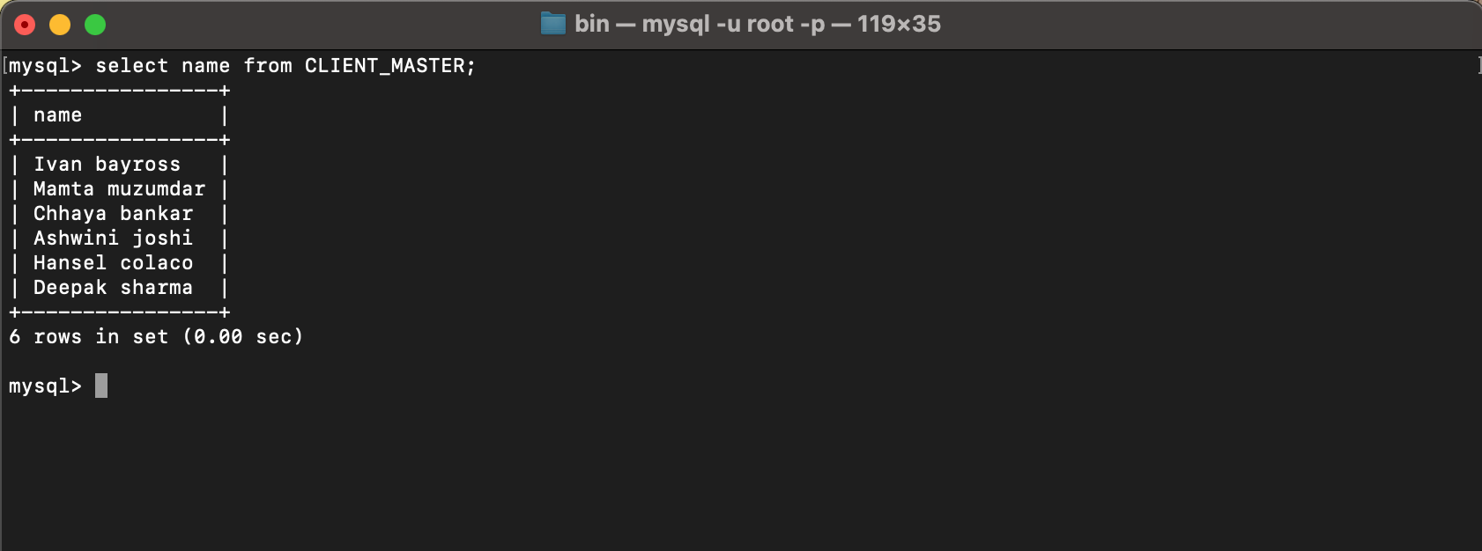  
b. Retrieve the entire contents of the Client_Master table.

**select * from CLIENT_MASTER;**

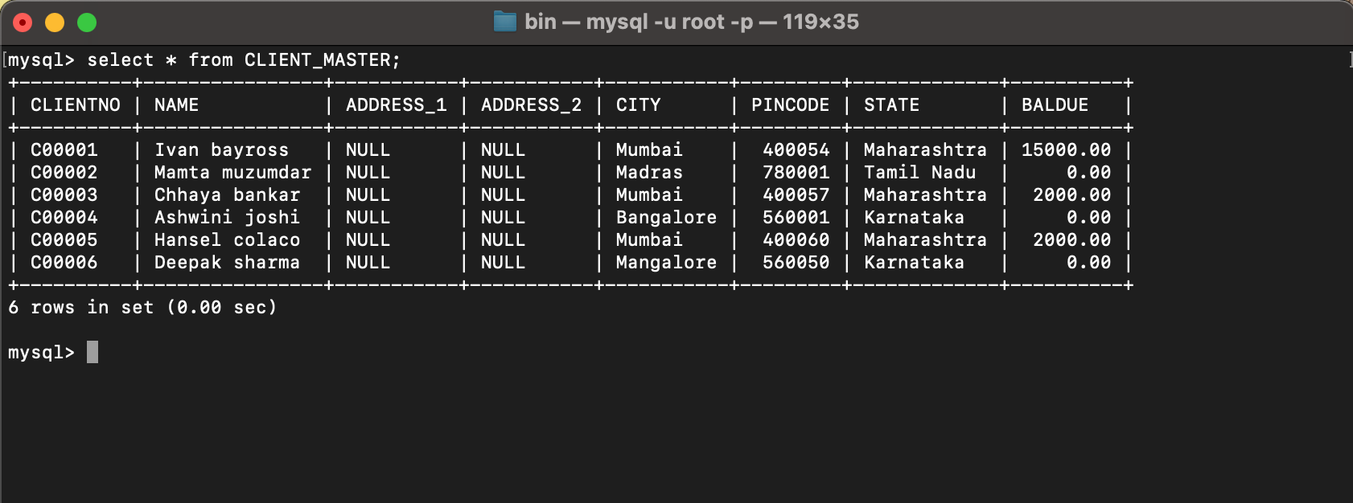  
c. Retrieve the list of names, city and the state of all the clients.

**select NAME, CITY, STATE from CLIENT_MASTER;**

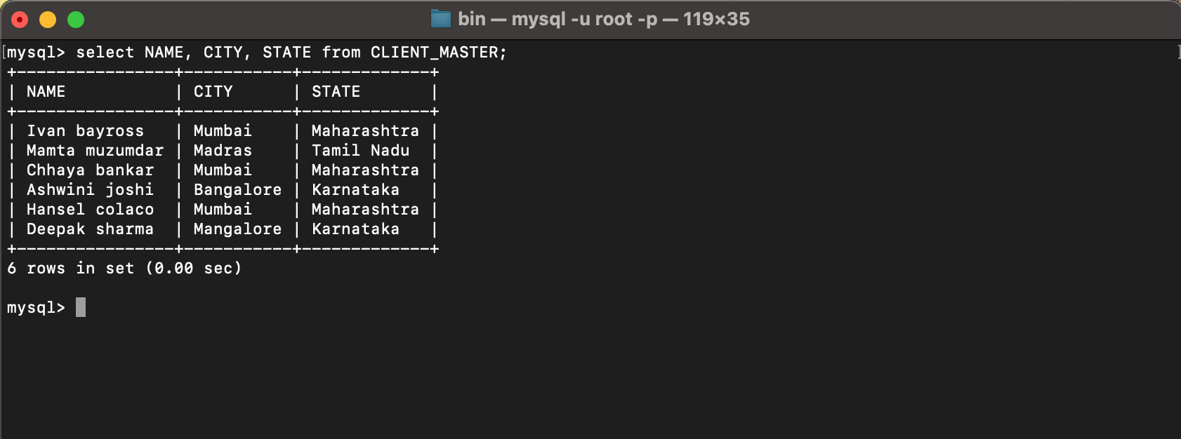

d. List the various products available from the Product_Master table.

**select DESCRIPTION from PRODUCT_MASTER;**

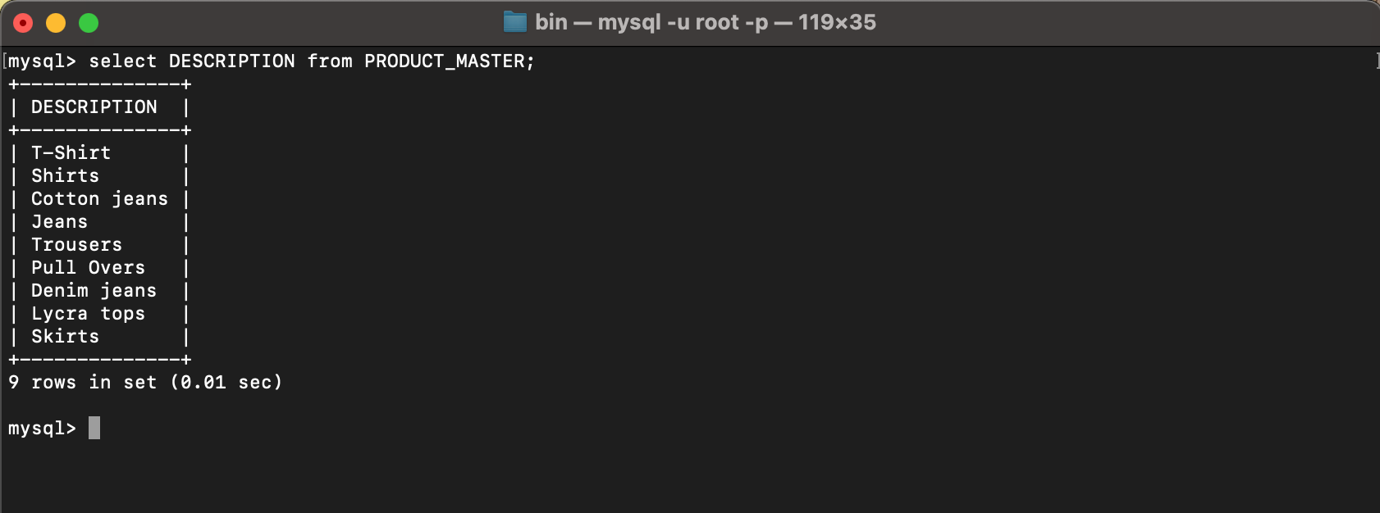  
e. List all the clients who are located in Mumbai.

**select NAME from CLIENT_MASTER where CITY='MUMBAI';**

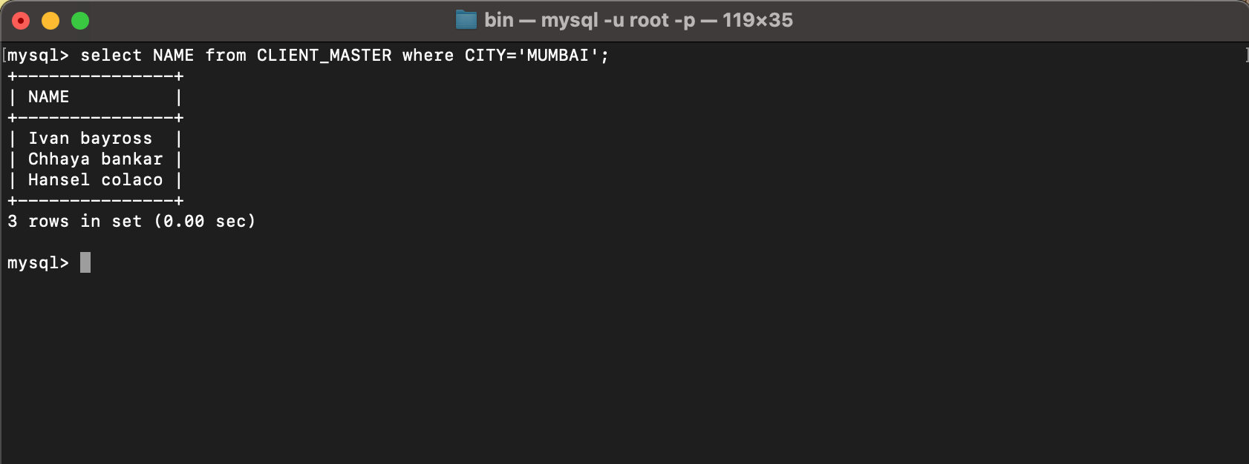  
f. Find the list of Product where QTYONHAND=100.

**select DESCRIPTION from PRODUCT_MASTER where QTYONHAND=100;**

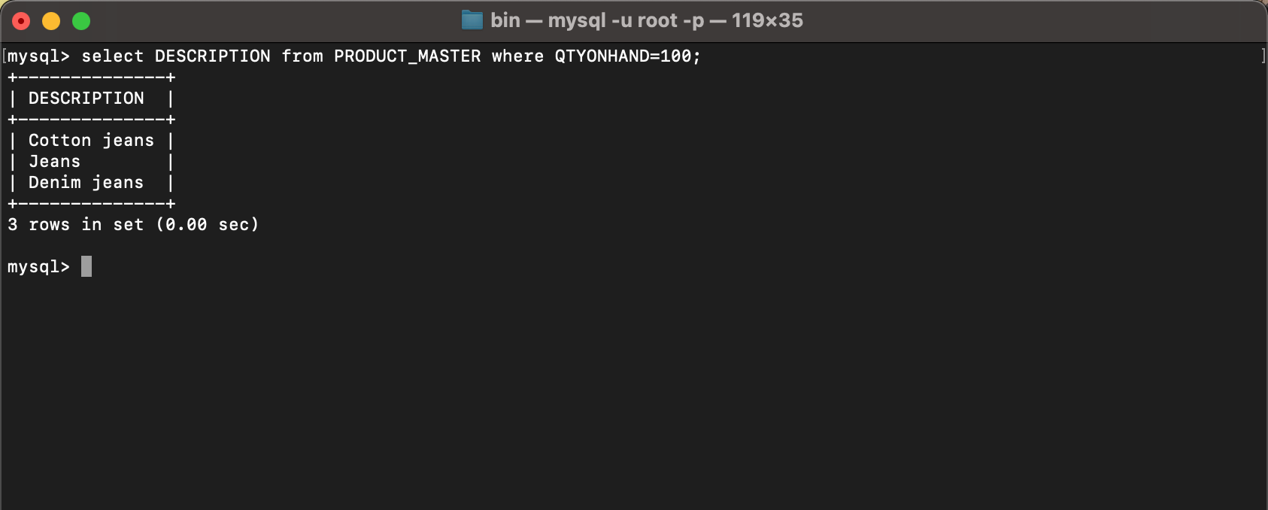

1. **Exercise on updating records in a table**  
   a. Change the city of ClientNo ‘C00005’ to ‘Bangalore’.  
   **update CLIENT_MASTER set CITY='BANGALORE' where CLIENTNO='C00005';**

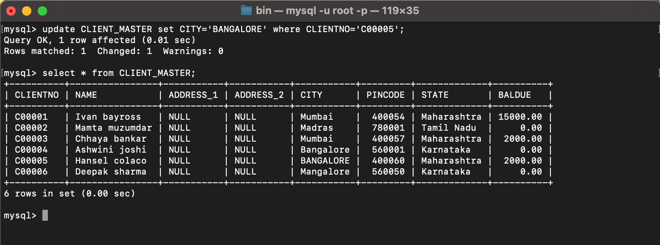  
b. Change the BalDue of ClientNo ‘C00001’ to Rs.1000.

**update CLIENT_MASTER set BALDUE=1000 where CLIENTNO='C00001';**

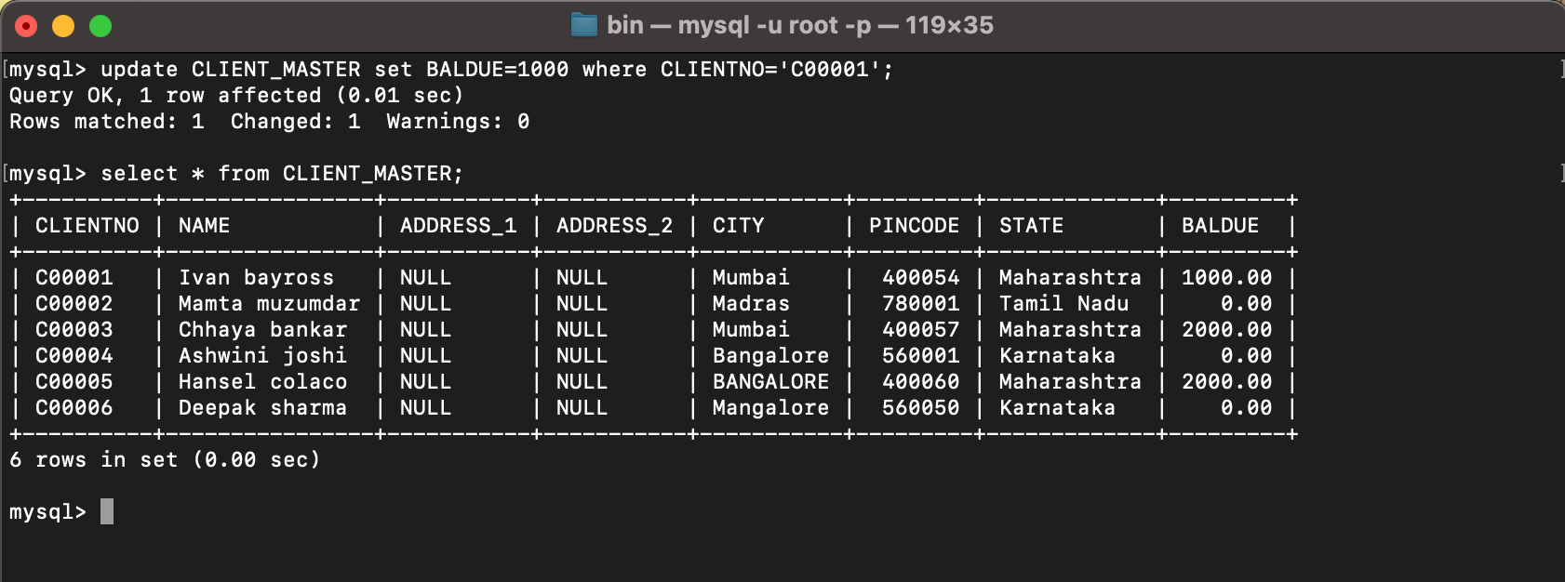  
c. Change the cost price of ‘Trousers’ to rs.950.00.

**update PRODUCT_MASTER set COSTPRICE=950 where DESCRIPTION='Trousers';**

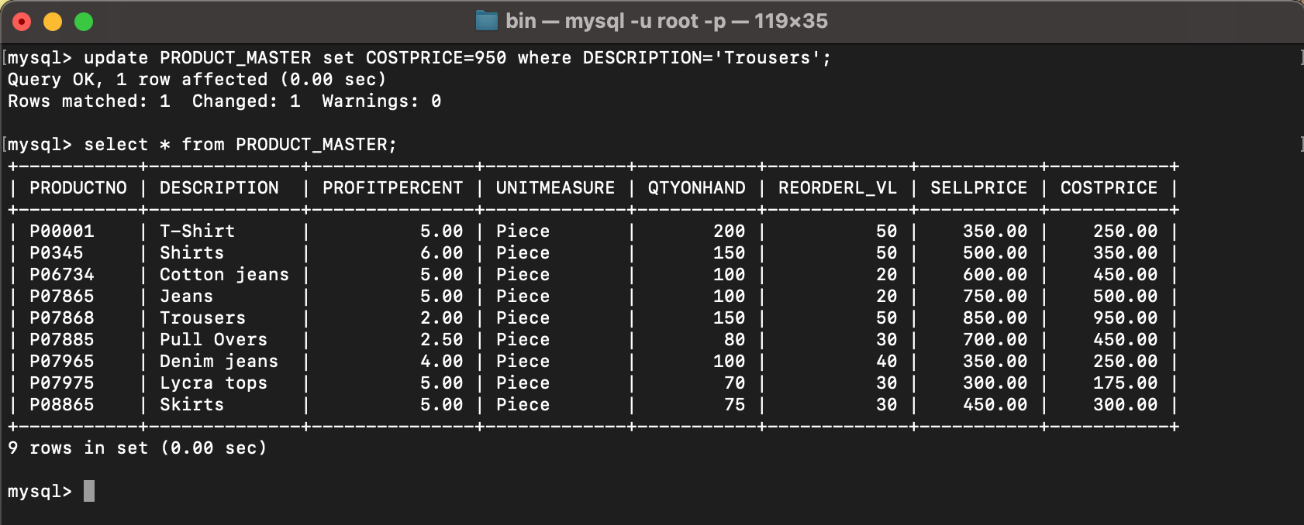

d. Change the city of the salesman to Pune.

**update SALESMAN_MASTER set CITY='PUNE';**

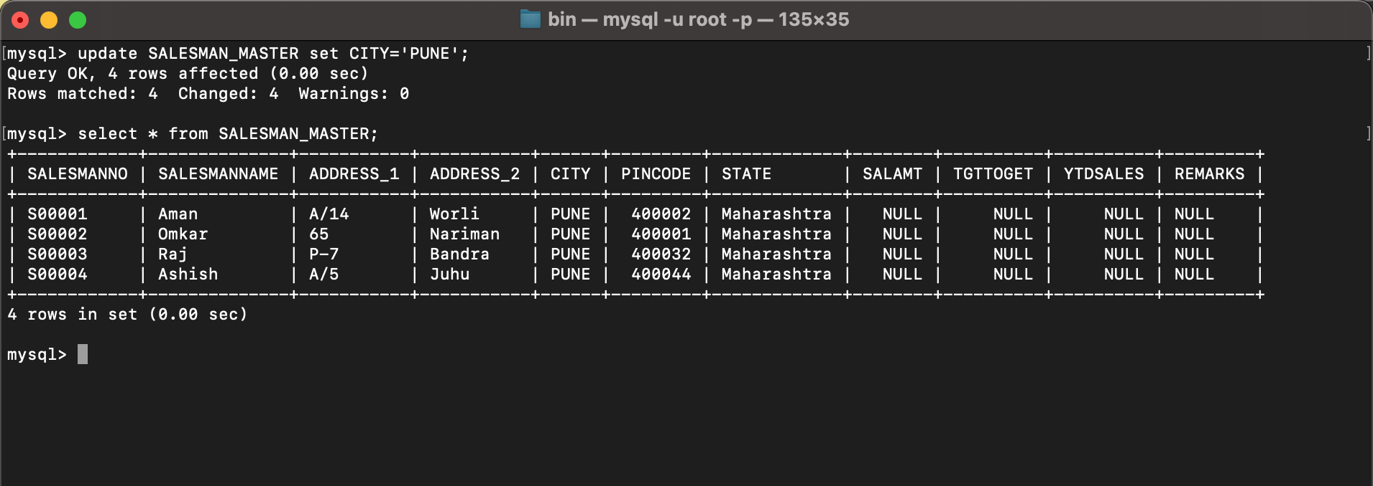

1. **Exercise on deleting records in a table**  
   a. Delete all salesman from the Salesman_Master whose salaries are equal to Rs.3500.

**delete from SALESMAN_MASTER where SALAMT=3500;**

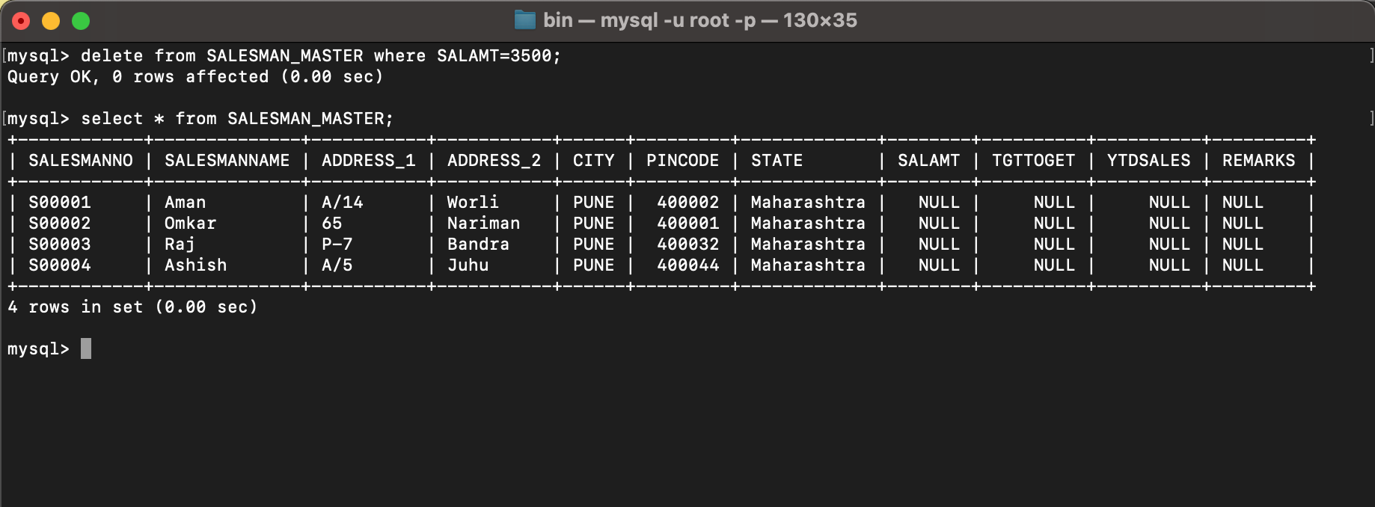

b. Delete all products from Product_Master where the quantity on hand is equal to 100.

**delete from PRODUCT_MASTER where QTYONHAND=100;**

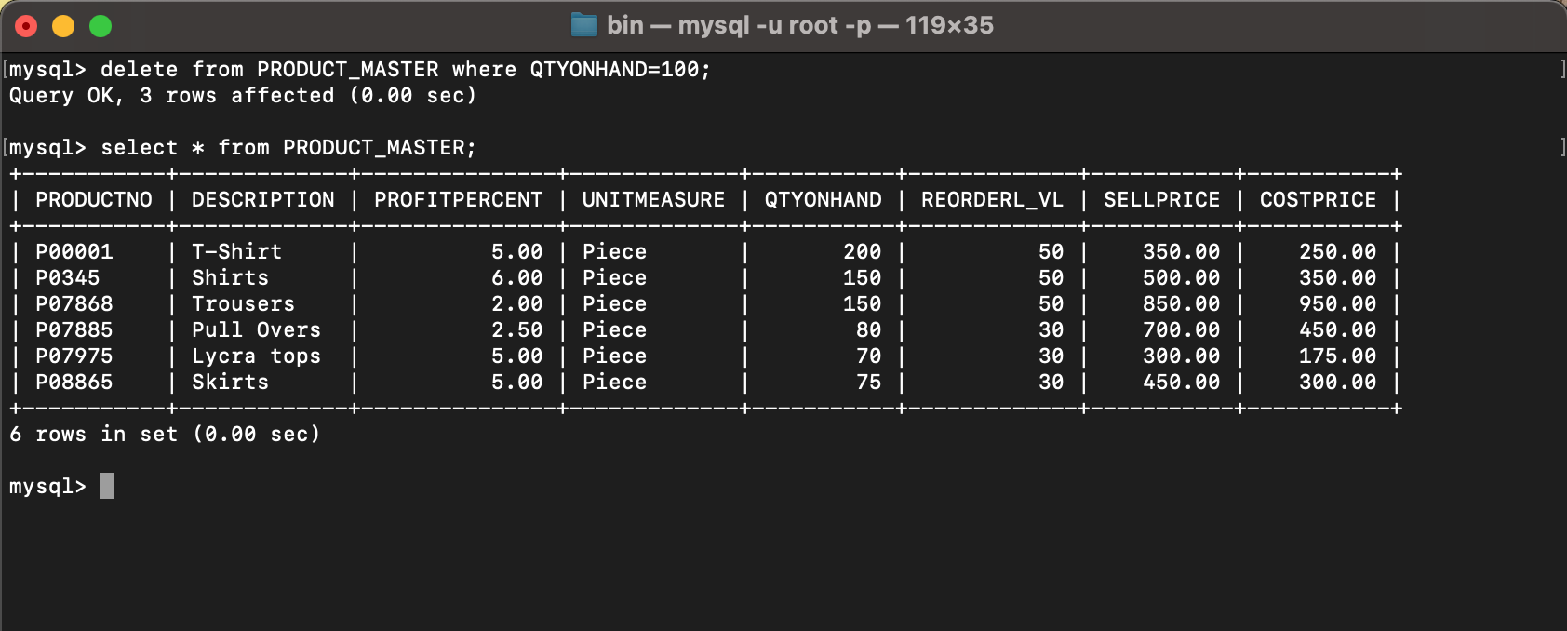

c. Delete from Client_Master where the column state holds the value ‘Tamil Nadu’.

**delete from CLIENT_MASTER where STATE='Tamil Nadu';**

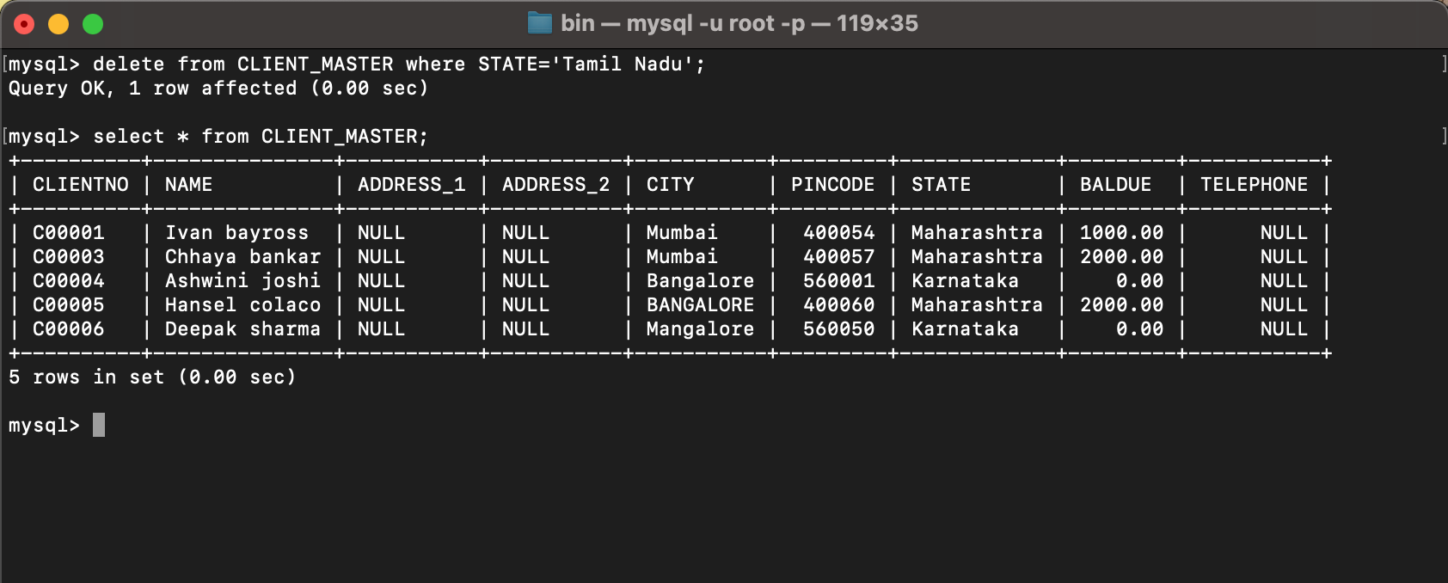

1. **Exercise on altering the table structure**  
   a. Add a column called ‘Telephone’ of data type integer to the Client_Master table.

**alter table CLIENT_MASTER add column TELEPHONE int;**

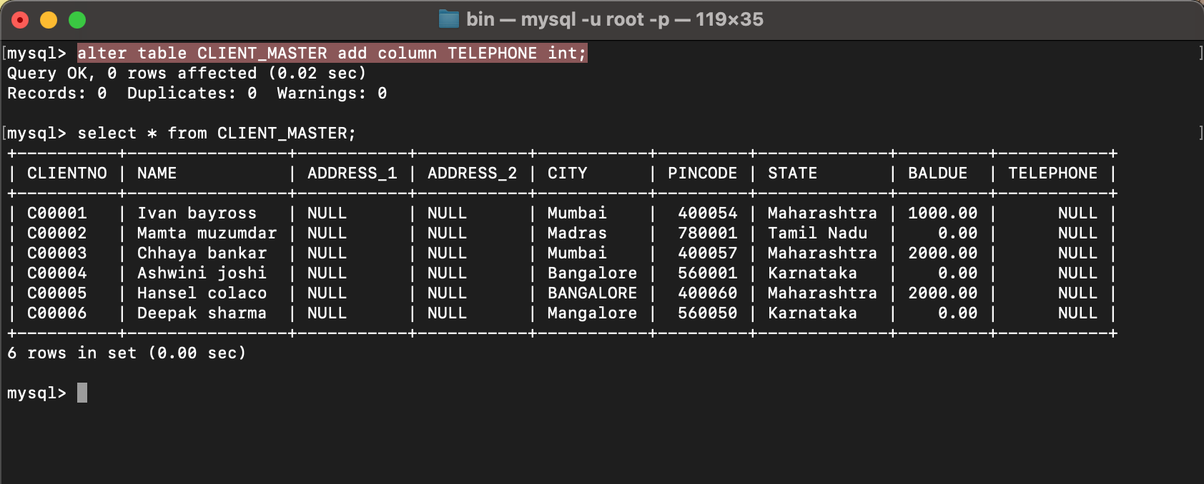

b. Change the size off SellPrice column in Product _Master to 10, 2.

**alter table PRODUCT_MASTER modify SELLPRICE decimal(10,2);**

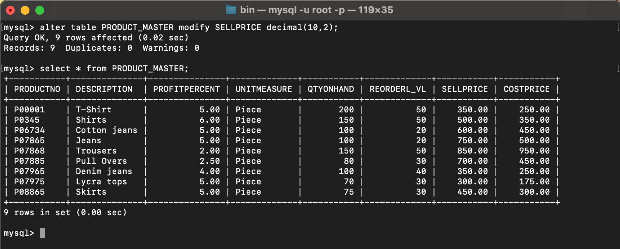

1. **Exercise on deleting the table structure along with the data**  
   a. Destroy the table Client_Master along with its data.

**drop table CLIENT_MASTER;**

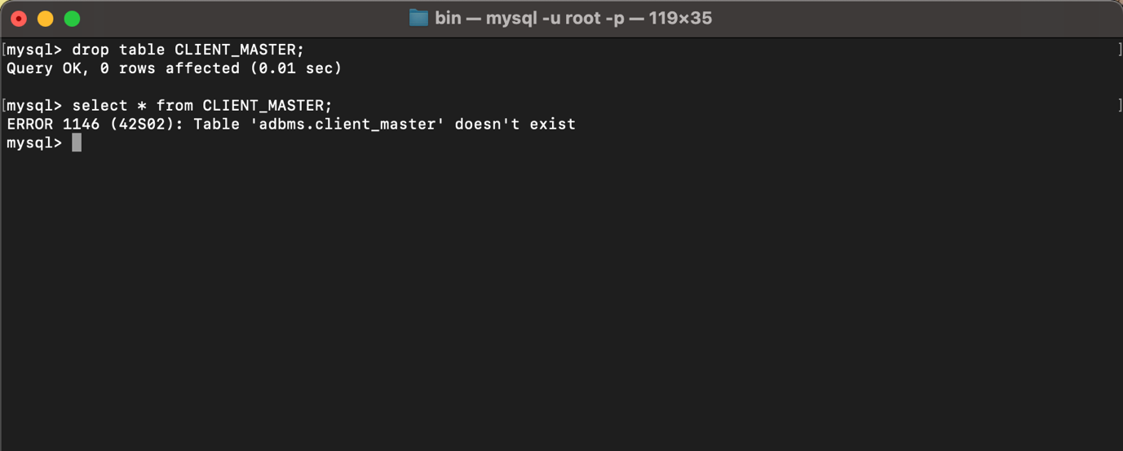

1. **Exercise on renaming the table**  
   a. Change the name of the Salesman_Master to sman_mast.

**alter table SALESMAN_MASTER rename to SMAN_MAST;**

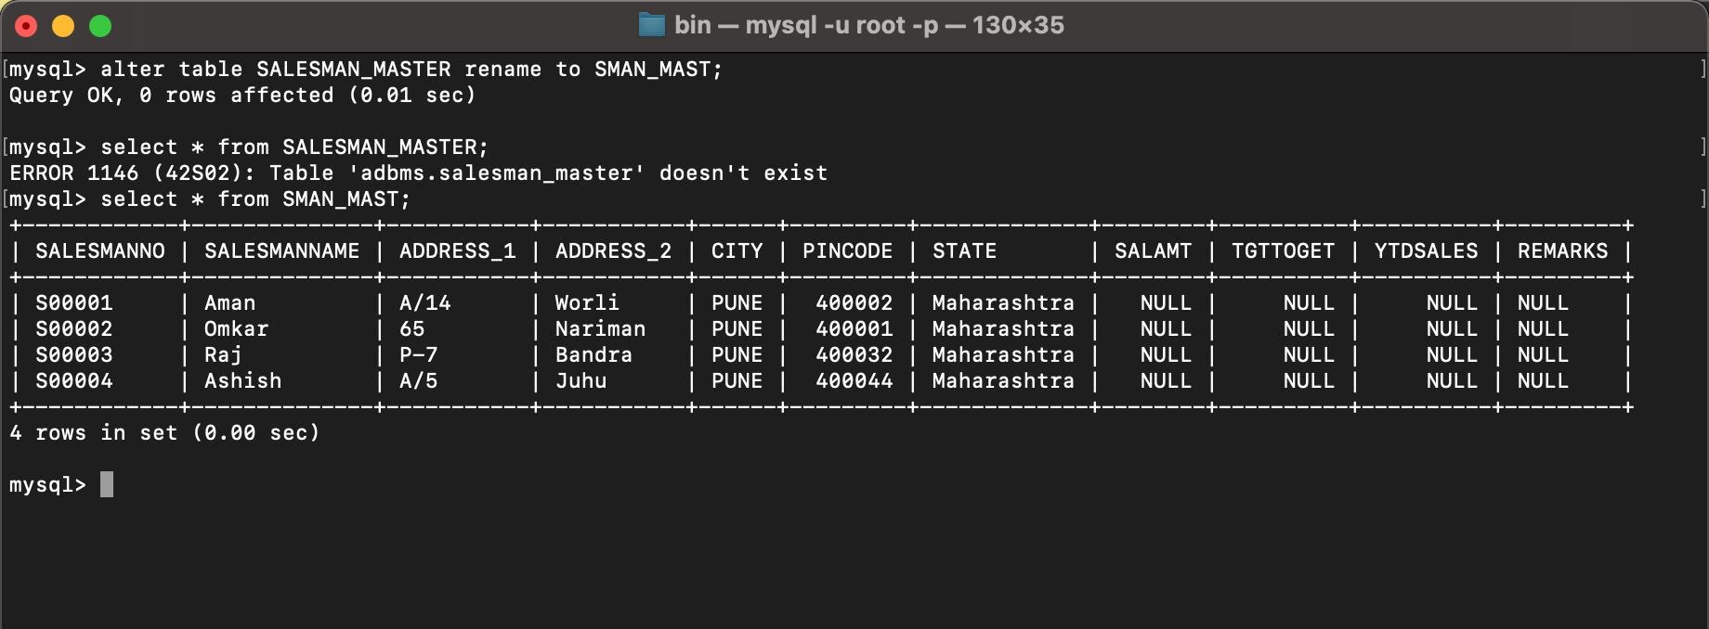

**LAB 2**

**EXPERIMENT-2**

**Title: 2. To understand and apply the concept of Constraints.**

**Objective:** To understand the concept of data constraints that is enforced on data being stored in the table. Focus on Primary Key and the Foreign Key.

**1. Create the tables described below:**

**Table name: CLIENT_MASTER_1**

**Description:** used to store client information.

| **Column name** | **data type** | **Size** | **Constraints** |
| --- | --- | --- | --- |
| CLIENTNO | Varchar | 6 | Primary key / first letter must start with ‘C’ |
| NAME | Varchar | 20 | Not Null |
| ADDRESS 1 | Varchar | 30 |  |
| ADDRESS 2 | Varchar | 30 |  |
| CITY | Varchar | 15 |  |
| PINCODE | Integer | 8 |  |
| STATE | Varchar | 15 |  |
| BALDUE | Decimal | 10,2 |  |

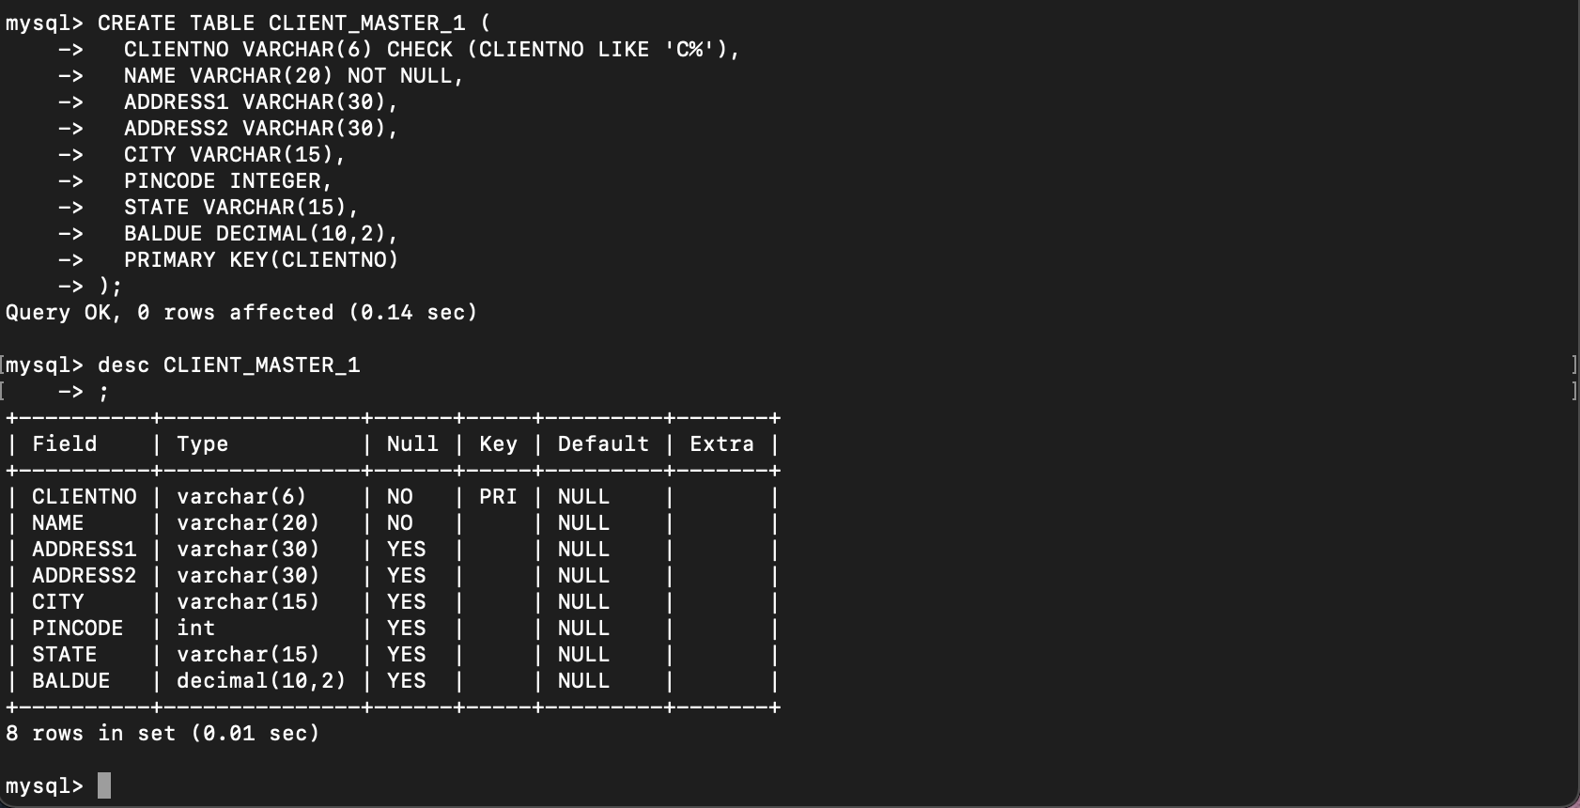

**Table Name: PRODUCT_MASTER_1 Description:** used to store product information

| **Column name** | **data type** | **Size** | **Attributes** |
| --- | --- | --- | --- |
| PRODUCTNO | Varchar | 6 | Primary Key/ first letter must start with ‘P’ |
| DESCRIPTION | Varchar | 15 | Not Null |
| PROFITPERCENT | Decimal | 4,2 | Not Null |
| UNIT MEASURE | Varchar | 10 | Not Null |
| QTYONHAND | Integer | 8 | Not Null |
| REORDERL VL | Integer | 8 | Not Null |
| SELLPRICE | Decimal | 8,2 | Not Null |
| COSTPRICE | Decimal | 8,2 | Not Null |

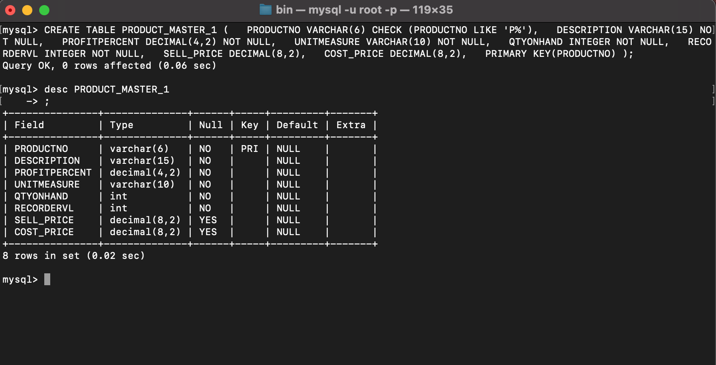

**Table Name: SALESMAN_MASTER _1**

**Description:**  used to store salesman information working for the company.

| **Column name** | **data type** | **Size** | **Attributes** |
| --- | --- | --- | --- |
| SALESMANNO | Varchar | 6 | Primary Key/ first letter must start with ‘S’ |
| SALESMANNAME | Varchar | 20 | Not Null |
| ADDRESS 1 | Varchar | 30 | Not Null |
| ADDRESS 2 | Varchar | 30 |  |
| CITY | Varchar | 20 |  |
| PINCODE | Integer | 8 |  |
| STATE | Varchar | 20 |  |
| SALAMT | Real | 8,2 | Not Null , Cannot be 0 |
| TGTTOGET | Decimal | 6,2 | Not Null , Cannot be 0 |
| YTDSALES | Double | 6,2 | Not Null |
| REMARKS | Varchar | 60 |  |

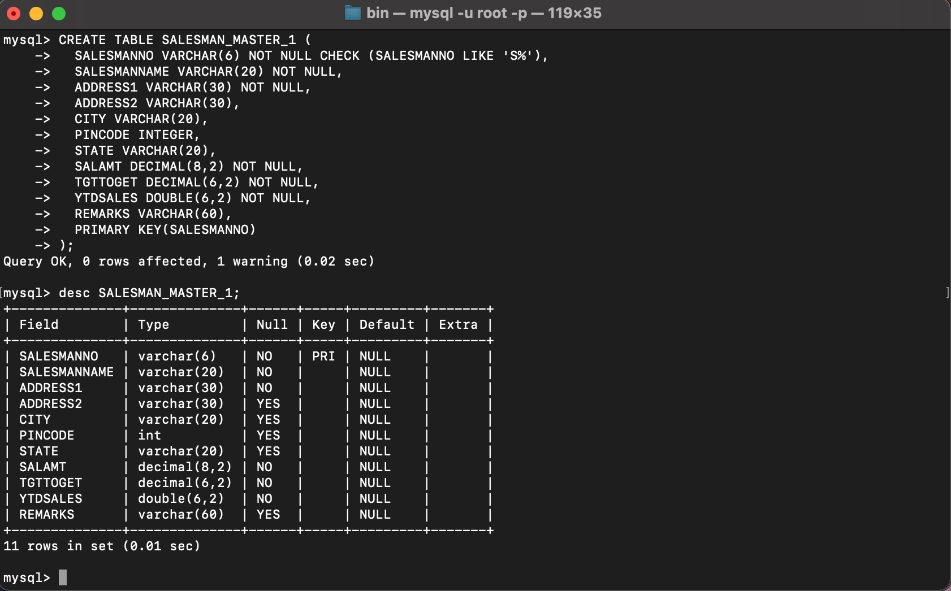

**2. Reinsert the data in these two tables based upon Lab 1.**

INSERT INTO CLIENT_MASTER_1 VALUES ('C00001', 'Ivan bayross', NULL, NULL, 'Mumbai', 400054, 'Maharashtra', 15000);

INSERT INTO CLIENT_MASTER_1 VALUES ('C00002', 'Mamta muzumdar', NULL, NULL, 'Madras', 780001, 'Tamil nadu', 0);

INSERT INTO CLIENT_MASTER_1 VALUES ('C00003', 'Chhaya bankar', NULL, NULL, 'Mumbai', 400057, 'Maharashtra', 5000);

INSERT INTO CLIENT_MASTER_1 VALUES ('C00004', 'Ashwini joshi', NULL, NULL, 'Bangalore', 560001, 'Karnataka', 0);

INSERT INTO CLIENT_MASTER_1 VALUES ('C00005', 'Hansel colaco', NULL, NULL, 'Mumbai', 400060, 'Maharashtra', 2000);

INSERT INTO CLIENT_MASTER_1 VALUES ('C00006', 'Deepak sharma', NULL, NULL, 'Mangalore', 560050, 'Karnataka', 0);

INSERT INTO PRODUCT_MASTER_1 VALUES ('P00001', 'T-shirt', 5, 'Piece', 200, 50, 350, 250);

INSERT INTO PRODUCT_MASTER_1 VALUES ('P0345', 'Shirts', 6, 'Piece', 150, 50, 500, 350);

INSERT INTO PRODUCT_MASTER_1 VALUES ('P06734', 'Cotton jeans', 5, 'Piece', 100, 20, 600, 450);

INSERT INTO PRODUCT_MASTER_1 VALUES ('P07865', 'Jeans', 5, 'Piece', 100, 20, 750, 500);

INSERT INTO PRODUCT_MASTER_1 VALUES ('P07868', 'Trousers', 2, 'Piece', 150, 50, 850, 550);

INSERT INTO PRODUCT_MASTER_1 VALUES ('P07885', 'Pull Overs', 2.5, 'Piece', 80, 30, 700, 450);

INSERT INTO PRODUCT_MASTER_1 VALUES ('P07965', 'Denim jeans', 4, 'Piece', 100, 40, 350, 250);

INSERT INTO PRODUCT_MASTER_1 VALUES ('P07975', 'Lycra tops', 5, 'Piece', 70, 30, 300, 175);

INSERT INTO PRODUCT_MASTER_1 VALUES ('PO8865', 'Skirts', 5, 'Piece', 75, 30, 450, 300);

INSERT INTO SALESMAN_MASTER_1 VALUES ('S00001', 'Aman', 'A/14', 'Worli', 'Mumbai', 400002, 'Maharashtra', 0, 0, 0, NULL);

INSERT INTO SALESMAN_MASTER_1 VALUES ('S00002', 'Omkar', '65', 'Nariman', 'Mumbai', 400001, 'Maharastra', 0, 0, 0, NULL);

INSERT INTO SALESMAN_MASTER_1 VALUES ('S00003', 'Raj', 'P-7', 'Bandra', 'Mumbai', 400032, 'Maharashtra', 0, 0, 0, NULL);

INSERT INTO SALESMAN_MASTER_1 VALUES ('S00004', 'Ashish', 'A/5', 'Juhu', 'Mumbai', 400044, 'Maharashtra', 0, 0, 0, NULL);

**3. Display the contents of each table.**

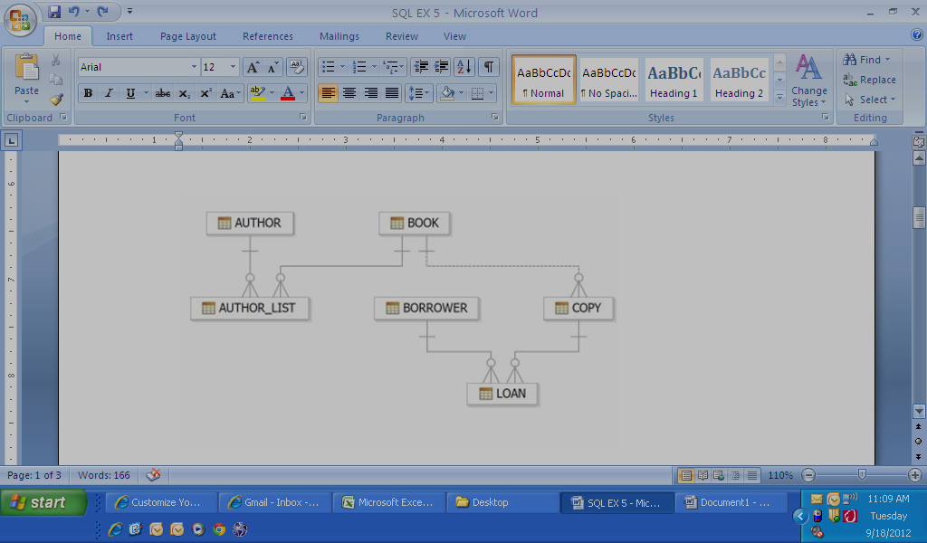

SELECT * FROM CLIENT_MASTER_1;

SELECT * FROM PRODUCT_MASTER_1;

SELECT * FROM SALESMAN_MASTER_1;

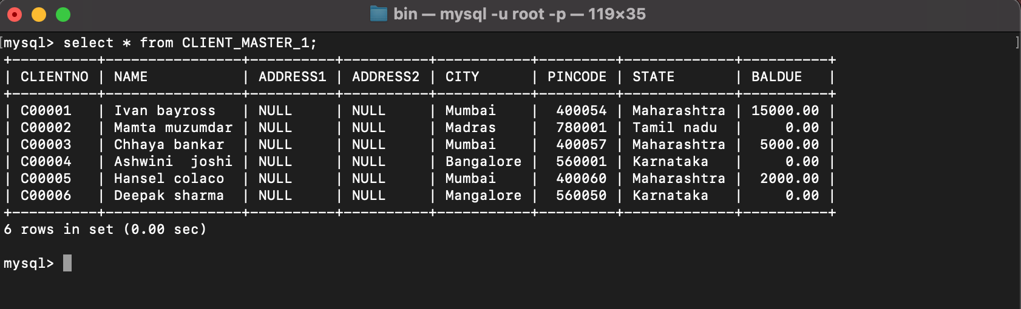

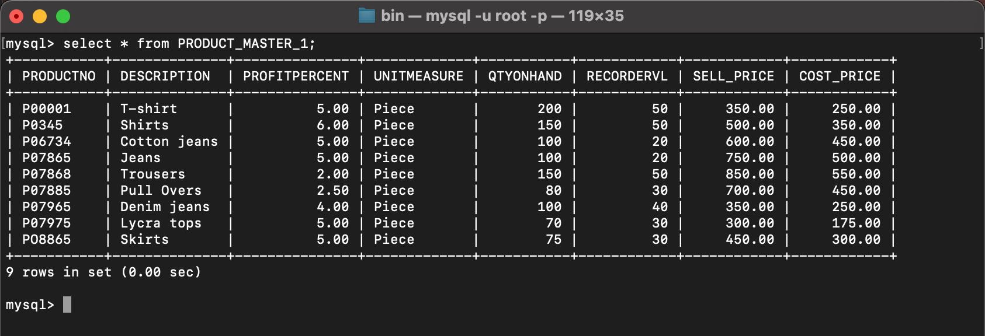

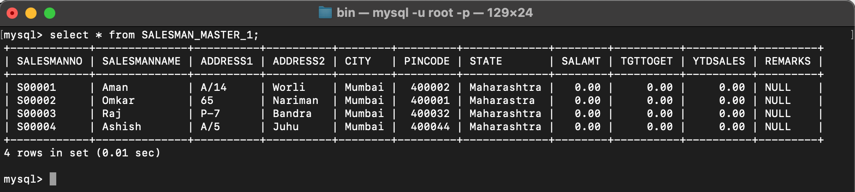

**4. Create table AUTHOR = {Author_ID , Lastname, Firstname, Email, City, Country}**

Where:

Author_ID – text data type, 5 characters, primary key

Lastname – text data type, 15 characters, not null

Firstname – text data type, 15 characters, not null

Email – text data type, 40 characters,

City – text data type, 15 characters,

Country – text data type, 15 characters,

CREATE TABLE AUTHOR(

AUTHOR_ID VARCHAR(5) PRIMARY KEY NOT NULL,

LASTNAME VARCHAR(15) NOT NULL,

FIRSTNAME VARCHAR(15) NOT NULL,

EMAIL VARCHAR(50),

CITY VARCHAR(15),

COUNTRY VARCHAR(15)

);

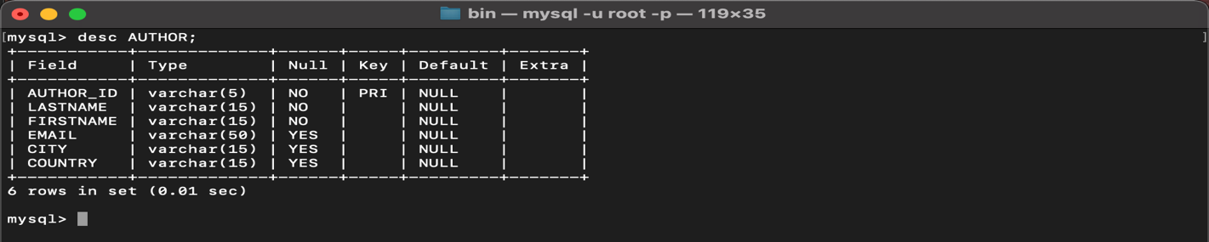

**5. Create Table BOOK={ Book_ID, Book_Title, Copies)**

Where :

Book_ID – text data type, 5 characters Primary Key Start With Character **B**

Book_Title - Text data Type Not Null

Copies- No.of copies Data Type int always greater the 2

CREATE TABLE BOOK(

BOOK_ID VARCHAR(5) PRIMARY KEY CHECK(BOOK_ID LIKE '%B'),

BOOKTITLE VARCHAR(40) NOT NULL,

COPIES INTEGER CHECK(COPIES>2) NOT NULL

);

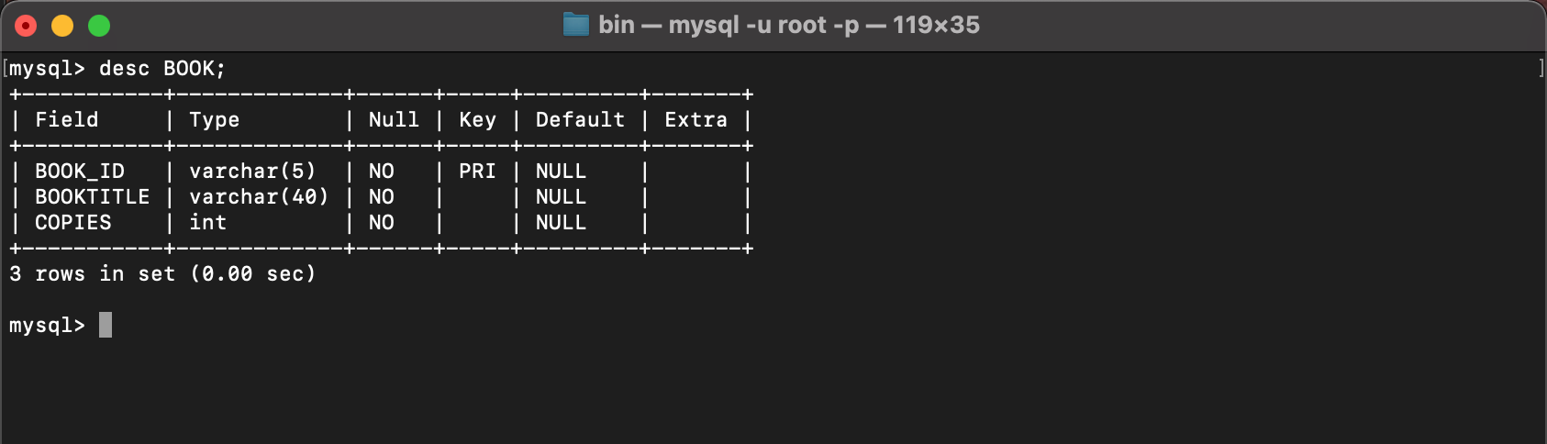

**6. Create table AUTHOR_LIST = {Author_ID , Book_ID , Role}**

Where:

Author_ID – text data type, 5 characters, referenced by Author_ID from AUTHOR

table

Book_ID – text data type, 5 characters

Role – text data type, 15 characters

and primary key is: Author_ID, Book_ID

CREATE TABLE AUTHOR_LIST(

AUTHOR_ID VARCHAR(5),

BOOK_ID VARCHAR(5),

ROLE VARCHAR(15),

PRIMARY KEY(AUTHOR_ID, BOOK_ID)

);

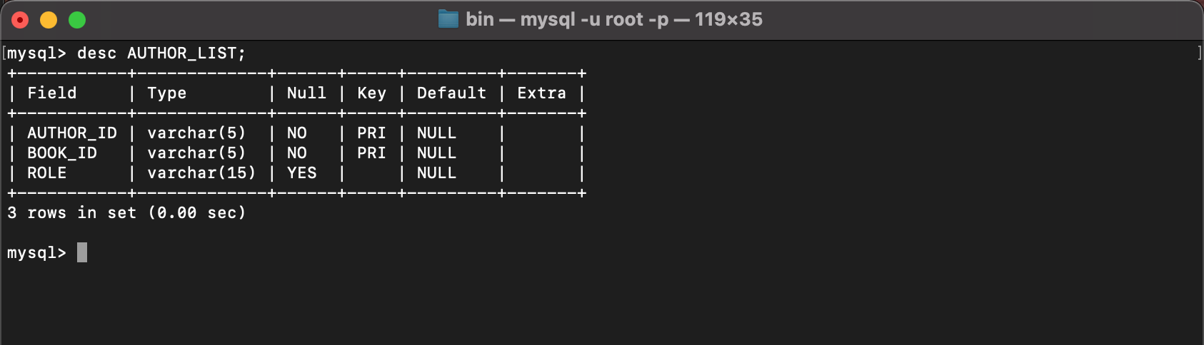

**7. Add four records in each tables AUTHOR, BOOK, BOOK_LIST.**

INSERT INTO AUTHOR VALUES ('A1001', 'GUSAIN', 'RAHUL', '500084143@stu.upes.ac.in', 'DEHRADUN', 'INDIA');

INSERT INTO AUTHOR VALUES ('A1002', 'KUMAR', 'ROHIT', '500082652@stu.upes.ac.in', 'DEHRADUN', 'INDIA');

INSERT INTO AUTHOR VALUES ('A1003', 'DUTTA', 'ANANYA', '500083514@stu.upes.ac.in', 'DEHRADUN', 'INDIA');

INSERT INTO AUTHOR VALUES ('A1004', 'BALODHI', 'VAISHNAV', '500082607@stu.upes.ac.in', 'DEHRADUN', 'INDIA');

INSERT INTO BOOK VALUES ('101B', 'PHILOSOPHY', 16);

INSERT INTO BOOK VALUES ('102B', 'PSYCHOLOGY', 25);

INSERT INTO BOOK VALUES ('103B', 'CSA', 18);

INSERT INTO BOOK VALUES ('104B', 'DSA', 19);

INSERT INTO AUTHOR_LIST VALUES ('A1001', '101B', 'WRITER');

INSERT INTO AUTHOR_LIST VALUES ('A1002', '102B', 'WRITER');

INSERT INTO AUTHOR_LIST VALUES ('A1003', '103B', 'WRITER');

INSERT INTO AUTHOR_LIST VALUES ('A1004', '104B', 'WRITER');

SELECT * FROM AUTHOR;

SELECT * FROM BOOK;

SELECT * FROM AUTHOR_LIST;

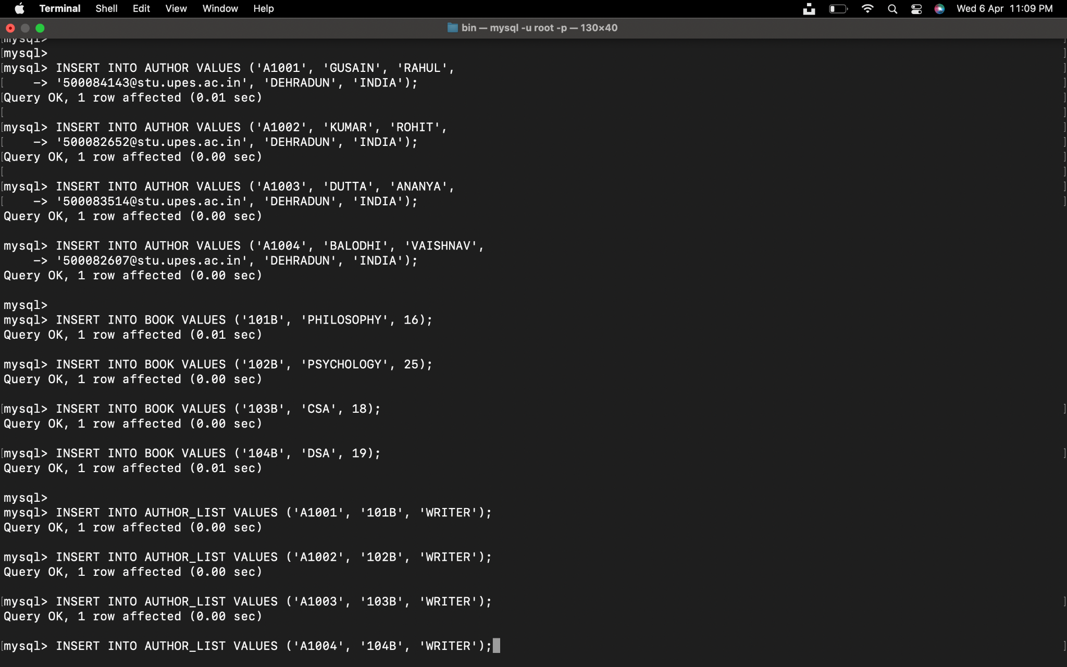

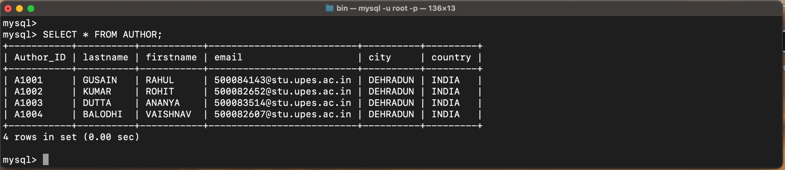

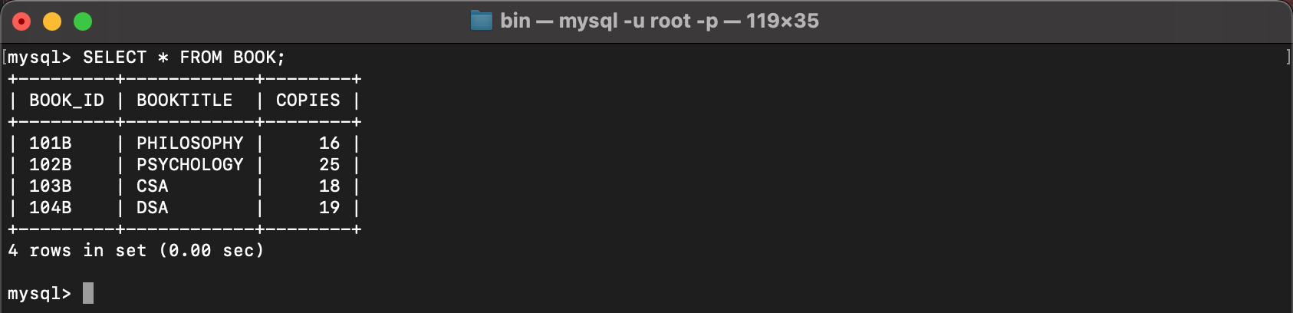

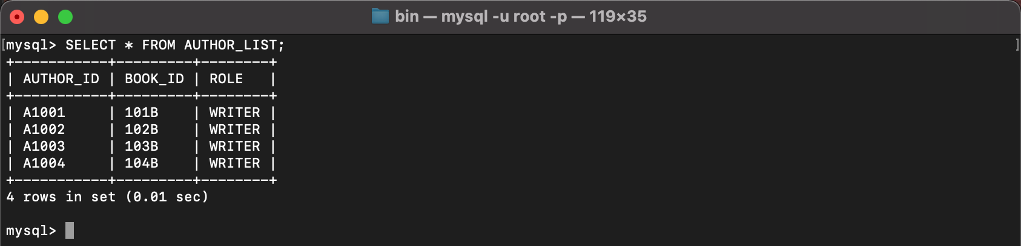

**8. Alter structure of table AUTHOR_LIST add the field Publisher data type of 30 Character.**

ALTER TABLE AUTHOR_LIST ADD PUBLISHER VARCHAR(30);

SELECT * FROM AUTHOR_LIST;

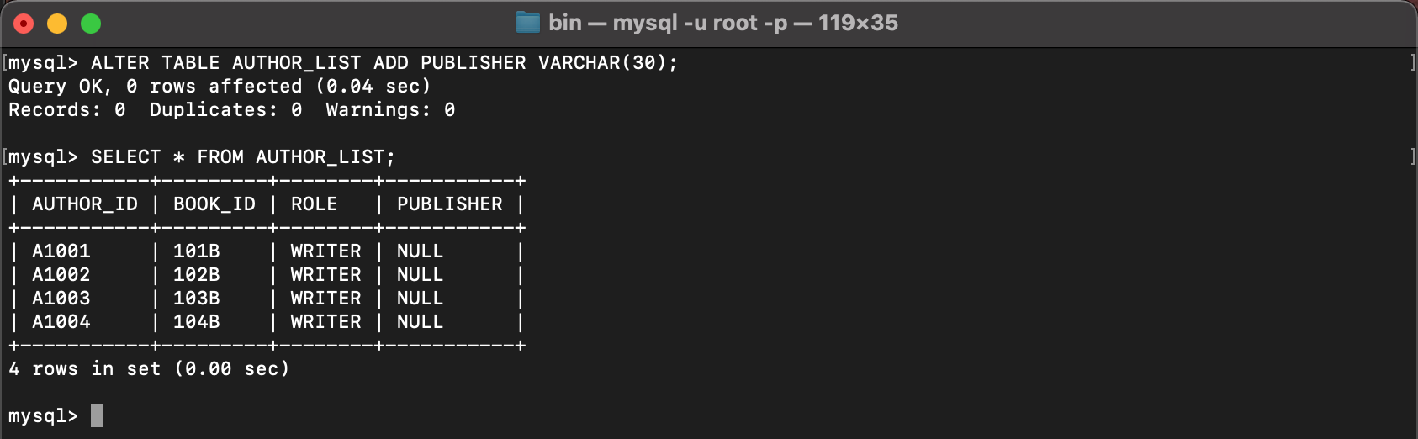

**LAB 3**

**Experiment-3**

**Title: 3. To understand and use SQL Sub-Query**

**Objective:** To understand the use of sql subquery.

**1. Create the following table.**

Supplier-(scode,sname,scity,turnover)

Part-(pcode,weigh,color,cost,sellingprice)

Supplier_Part-(scode,pcode,qty)

CREATE TABLE SUPPLIER(SCODE VARCHAR(6) PRIMARY KEY, SNAME VARCHAR(20) ,SCITY VARCHAR(30),TURNOVER INT);

CREATE TABLE PART(PCODE VARCHAR(6) PRIMARY KEY, WEIGH INT , COLOR VARCHAR(30),COST INT,SELLINGPRICE INT);

CREATE TABLE SUPPLIER_PART(SCODE VARCHAR(6) , PCODE VARCHAR(6) , QTY INT, PRIMARY KEY(SCODE,PCODE), FOREIGN KEY (SCODE) REFERENCES SUPPLIER (SCODE), FOREIGN KEY (PCODE) REFERENCES PART (PCODE));

DESCRIBE TABLE SUPPLIER;

DESCRIBE TABLE PART;

DESCRIBE SUPPLIER_PART;

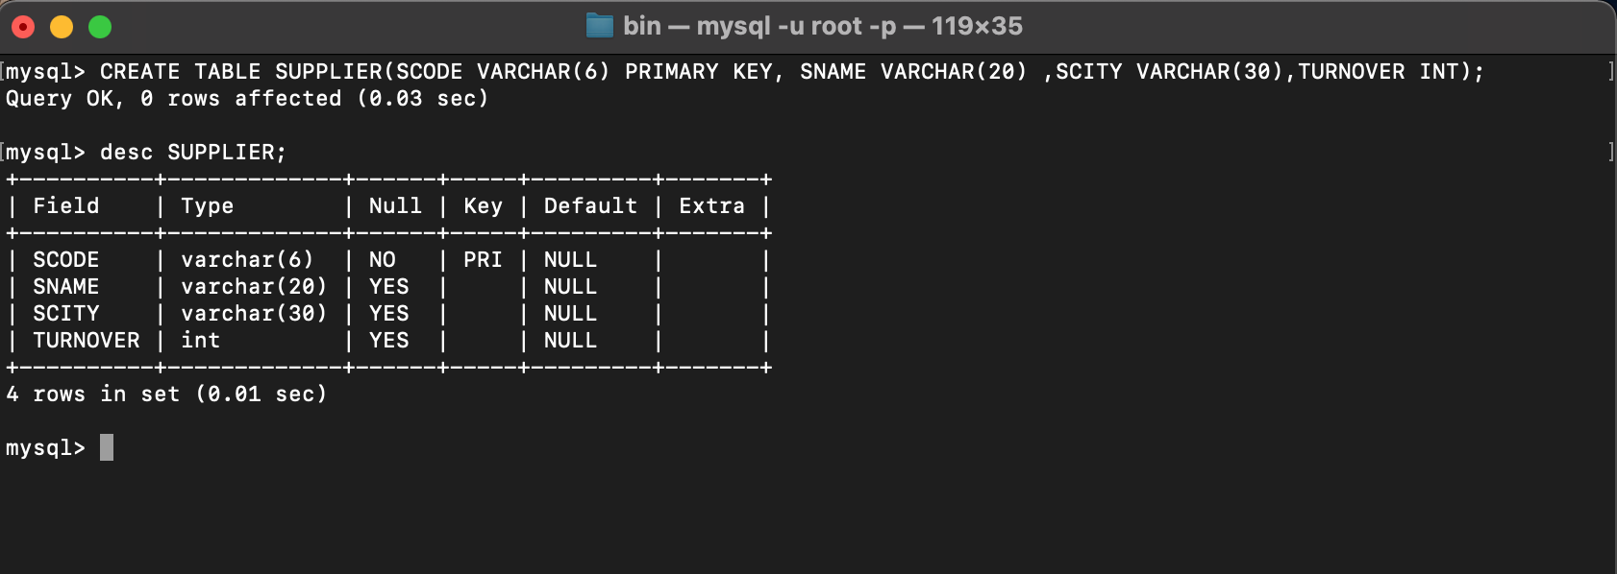

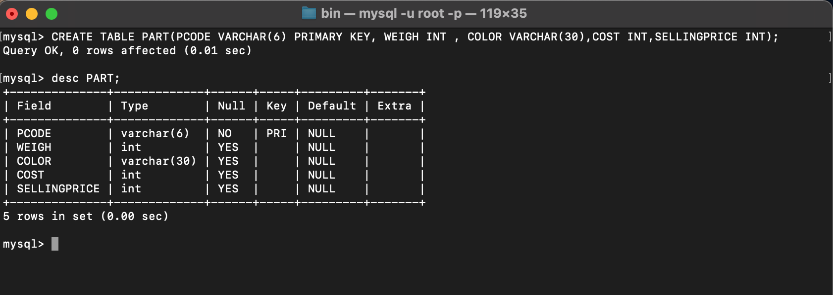

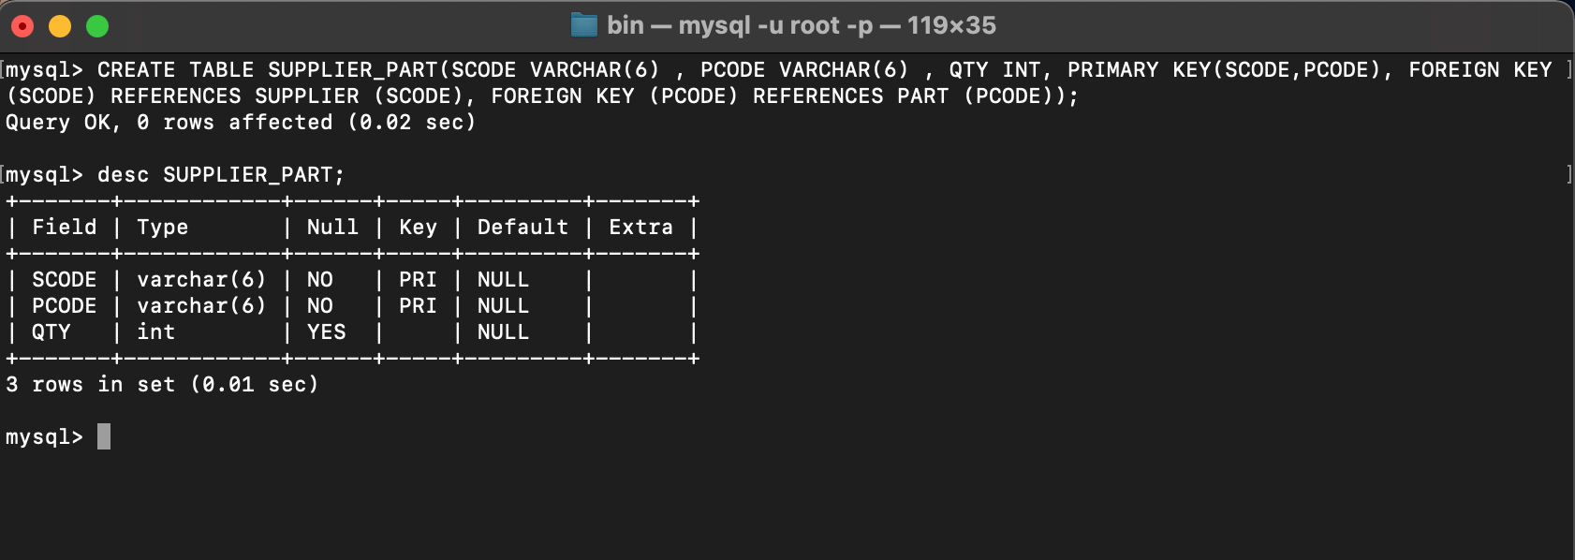

**2. Populate the table**

INSERT INTO SUPPLIER VALUES ('S00001', 'Rahul','Dehradun',500000);

INSERT INTO SUPPLIER VALUES ('S00002', 'Abhipriya','Bhagalpur', 550000);

INSERT INTO SUPPLIER VALUES ('S00003', 'Ananya','Mangalore',400000);

INSERT INTO SUPPLIER VALUES ('S00004', 'Bhoomi','Lalitpur',NULL);

INSERT INTO SUPPLIER VALUES ('S00005', 'Disha','Bombay',350000);

INSERT INTO PART VALUES ('P00001', 70 ,'BLACK',10,20);

INSERT INTO PART VALUES ('P00002', 22,'TURQUOISE',30,60);

INSERT INTO PART VALUES ('P00003', 24,'WHITE',12,40);

INSERT INTO PART VALUES ('P00004', 14,'PINK',20,30);

INSERT INTO PART VALUES ('P00005', 34,'RED',40,80);

INSERT INTO SUPPLIER_PART VALUES ('S00001', 'P00001', 100 );

INSERT INTO SUPPLIER_PART VALUES ('S00002', 'P00002', 50);

INSERT INTO SUPPLIER_PART VALUES ('S00003', 'P00003', 40 );

INSERT INTO SUPPLIER_PART VALUES ('S00004', 'P00004', 68);

INSERT INTO SUPPLIER_PART VALUES ('S00005', 'P00005', 50);

SELECT * FROM SUPPLIER;

SELECT * FROM PART;

SELECT * FROM SUPPLIER_PART;

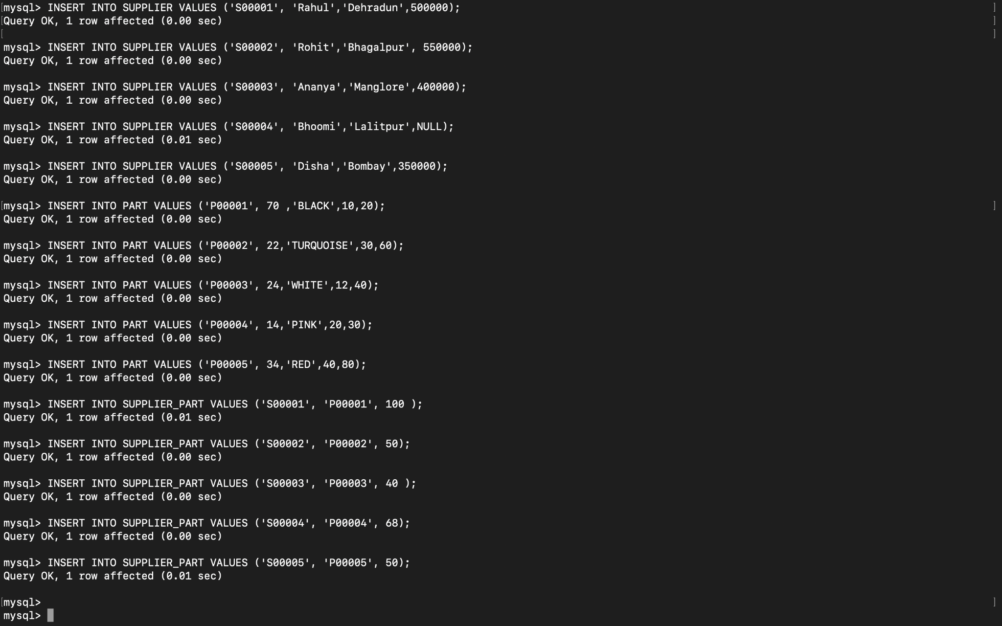

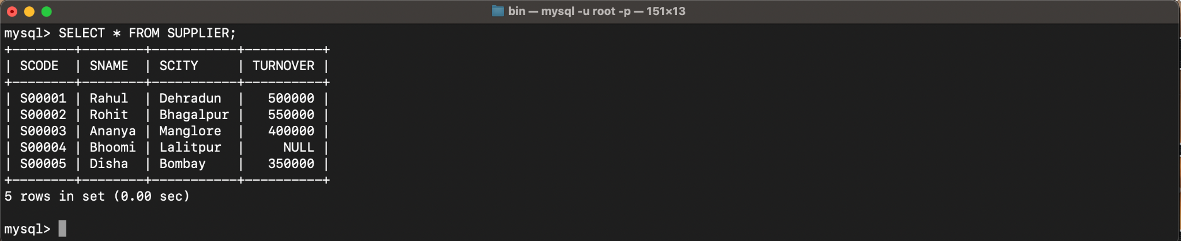

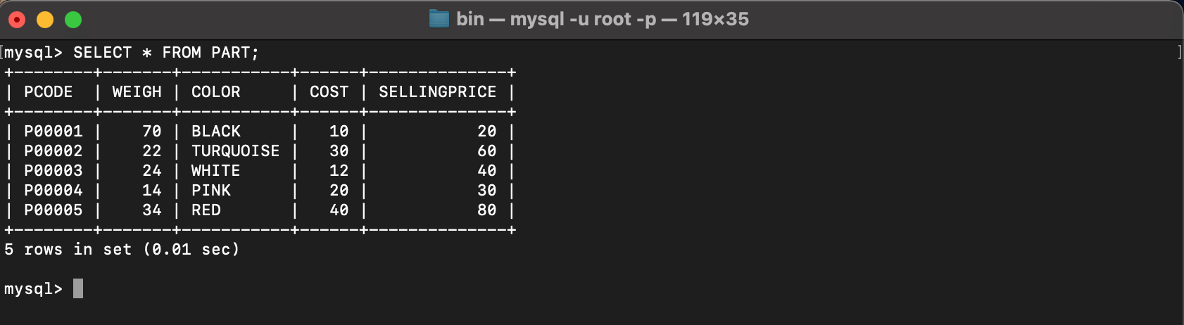

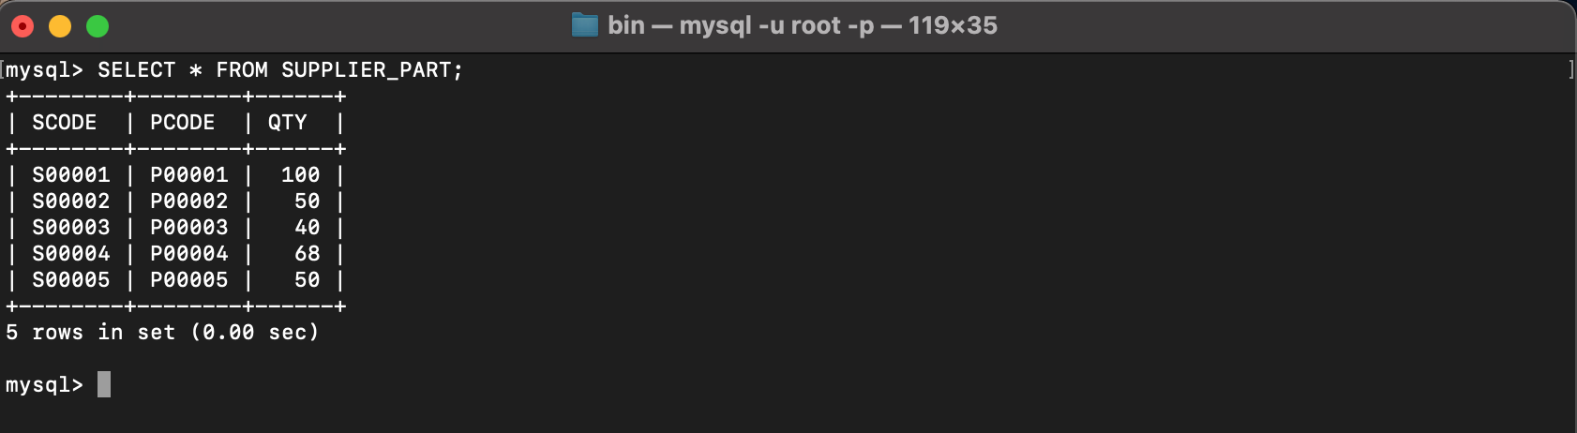

**3. Write appropriate SQL Statement for the following:**

1. Get the supplier number and part number in ascending order of supplier number.

SELECT SCODE, PCODE FROM SUPPLIER_PART ORDER BY SCODE ASC;

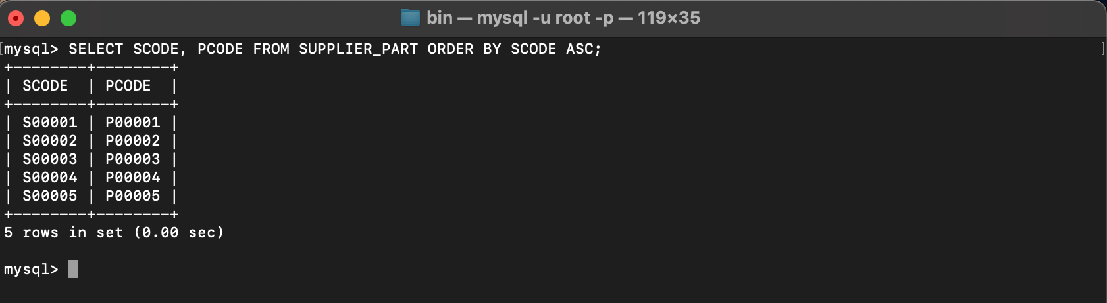

2. Get the details of supplier who operate from Bombay with turnover 50.

SELECT * FROM SUPPLIER WHERE SCITY='Bombay' AND TURNOVER>50;

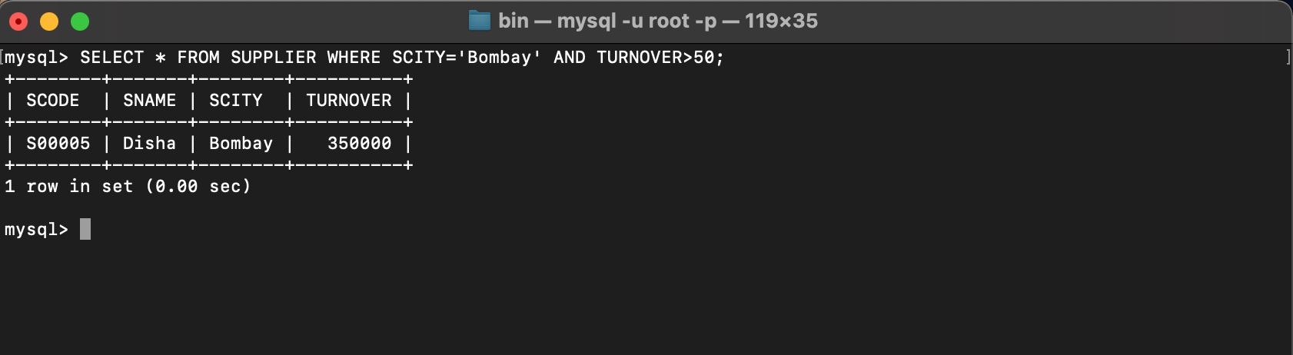

3. Get the total number of supplier.

SELECT COUNT(SCODE) FROM SUPPLIER;

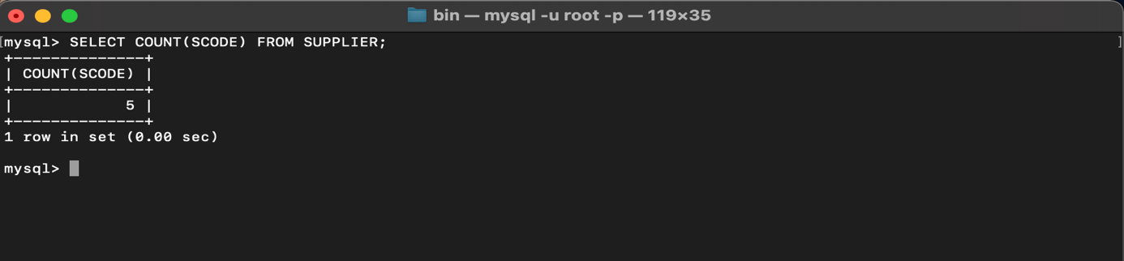

4. Get the part number weighing between 25 and 35.

SELECT PCODE, WEIGH FROM PART WHERE WEIGH BETWEEN 25 AND 35;

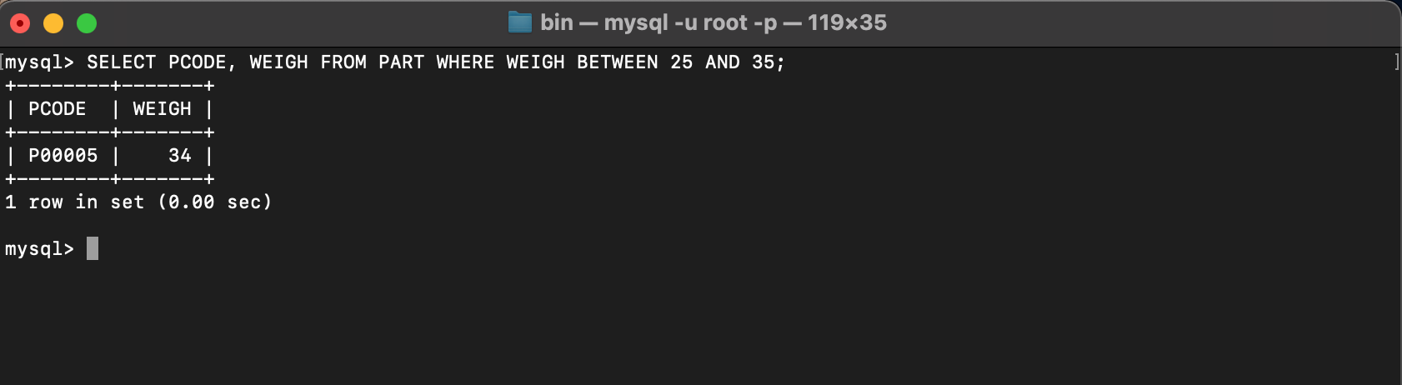

5. Get the supplier number whose turnover is null.

SELECT SCODE FROM SUPPLIER WHERE TURNOVER IS NULL;

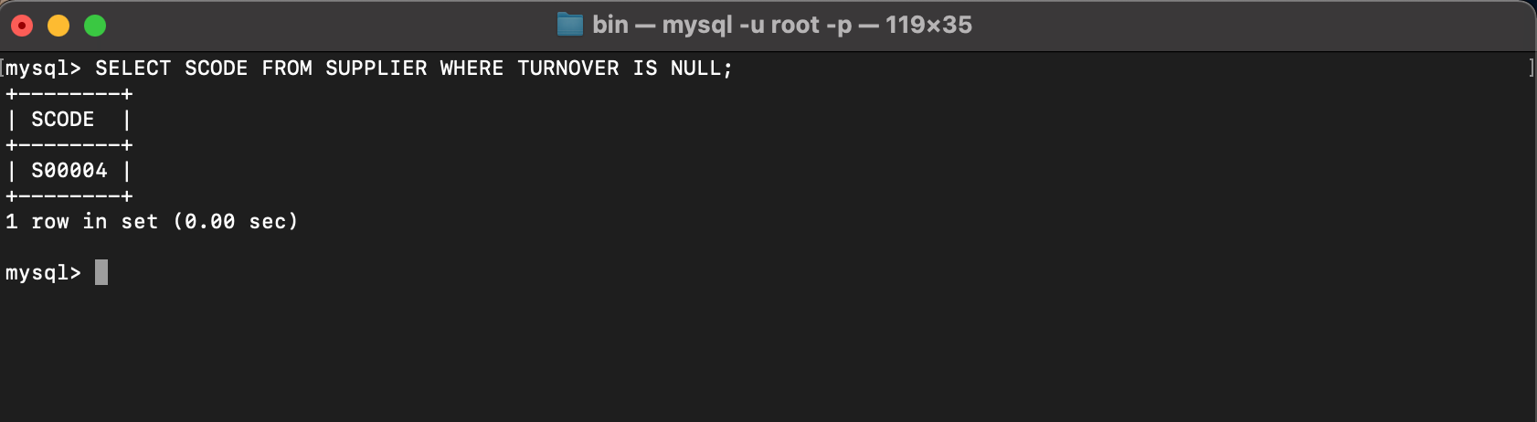

6. Get the part number that cost 20, 30 or 40 rupees.

SELECT PCODE, SELLINGPRICE FROM PART WHERE SELLINGPRICE IN (20,30,40);

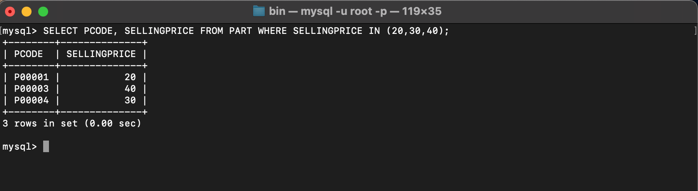

7. Get the total quantity of part 2 that is supplied.

SELECT SUM(SUPPLIER_PART.QTY) FROM SUPPLIER_PART WHERE SUPPLIER_PART.PCODE='P00002';

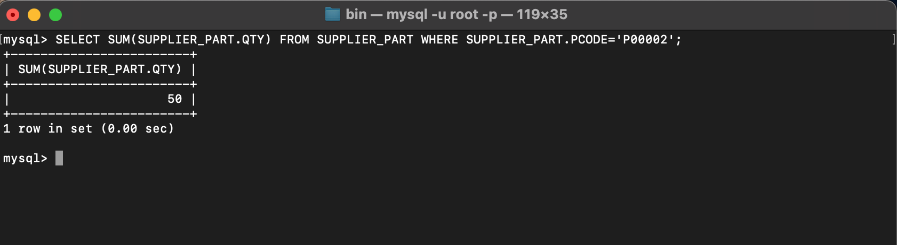

8. Get the name of supplier who supply part 2.

SELECT SNAME FROM SUPPLIER WHERE SCODE =(SELECT SCODE FROM SUPPLIER_PART WHERE PCODE='P00002');

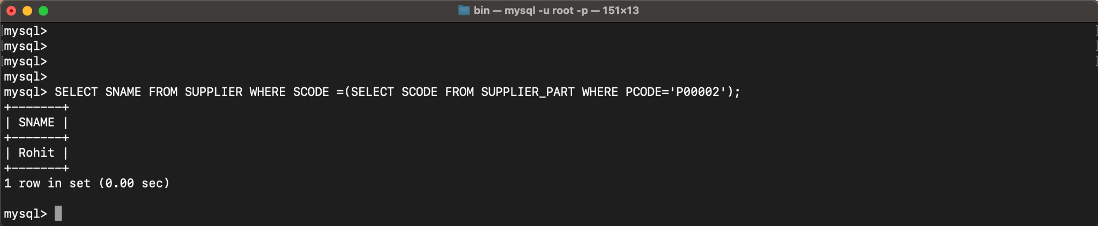

9. Get the part number whose cost is greater than the average cost.

SELECT PCODE FROM PART WHERE COST>(SELECT AVG (COST) FROM PART);

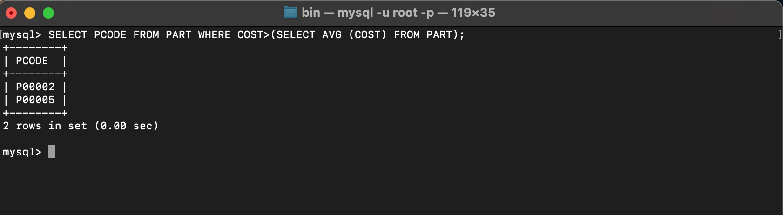

10. Get the supplier number and turnover in descending order of turnover.

SELECT SCODE, TURNOVER FROM SUPPLIER ORDER BY TURNOVER DESC;

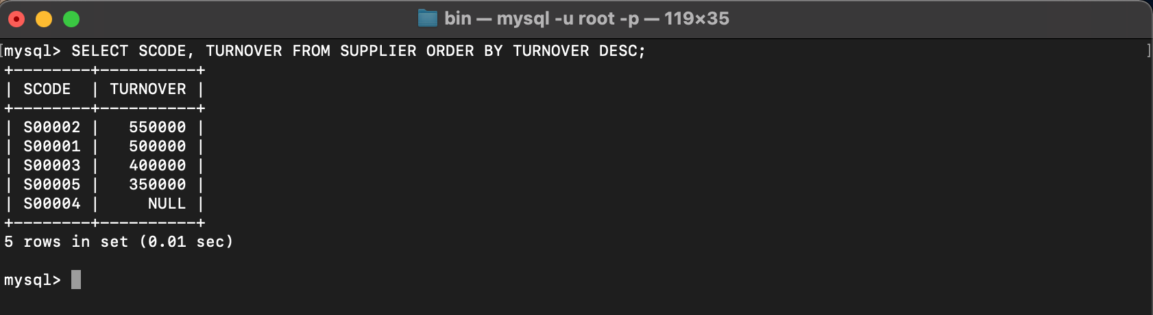

**LAB 4**

**EXPERIMENT-4**

**Title: 4. Use of Inbuilt functions and relational algebra operation**

**Objective:** To understand the use of inbuilt function and relational algebra with sql query.

1. **Create the following two tables (EMP and DEPT)**

**EMP TABLE**

EMPNO ENAME JOB MGR HIREDATE SAL COMM DEPTNO

---------- ---------- --------- ---------- --------- ---------- ---------- ----------

7369 SMITH CLERK 7902 17-DEC-80 500 800 20

7499 ALLEN SALESMAN 7698 20-FEB-81 1600 300 30

7521 WARD SALESMAN 7698 22-FEB-81 1250 500 30

7566 JONES MANAGER 7839 02-APR-81 2975 20

7654 MARTIN SALESMAN 7698 28-SEP-81 1250 1400 30

7698 BLAKE MANAGER 7839 01-MAY-81 2850 30

7782 CLARK MANAGER 7839 09-JUN-81 2450 10

7788 SCOTT ANALYST 7566 09-DEC-82 3000 20

7839 KING PRESIDENT 17-NOV-81 5000 10

7844 TURNER SALESMAN 7698 08-SEP-81 1500 0 30

7876 ADAMS CLERK 7788 12-JAN-83 1100 20

7900 JAMES CLERK 7698 03-DEC-81 950 30

7902 FORD ANALYST 7566 03-DEC-81 3000 20

7934 MILLER CLERK 7782 23-JAN-82 1300 10

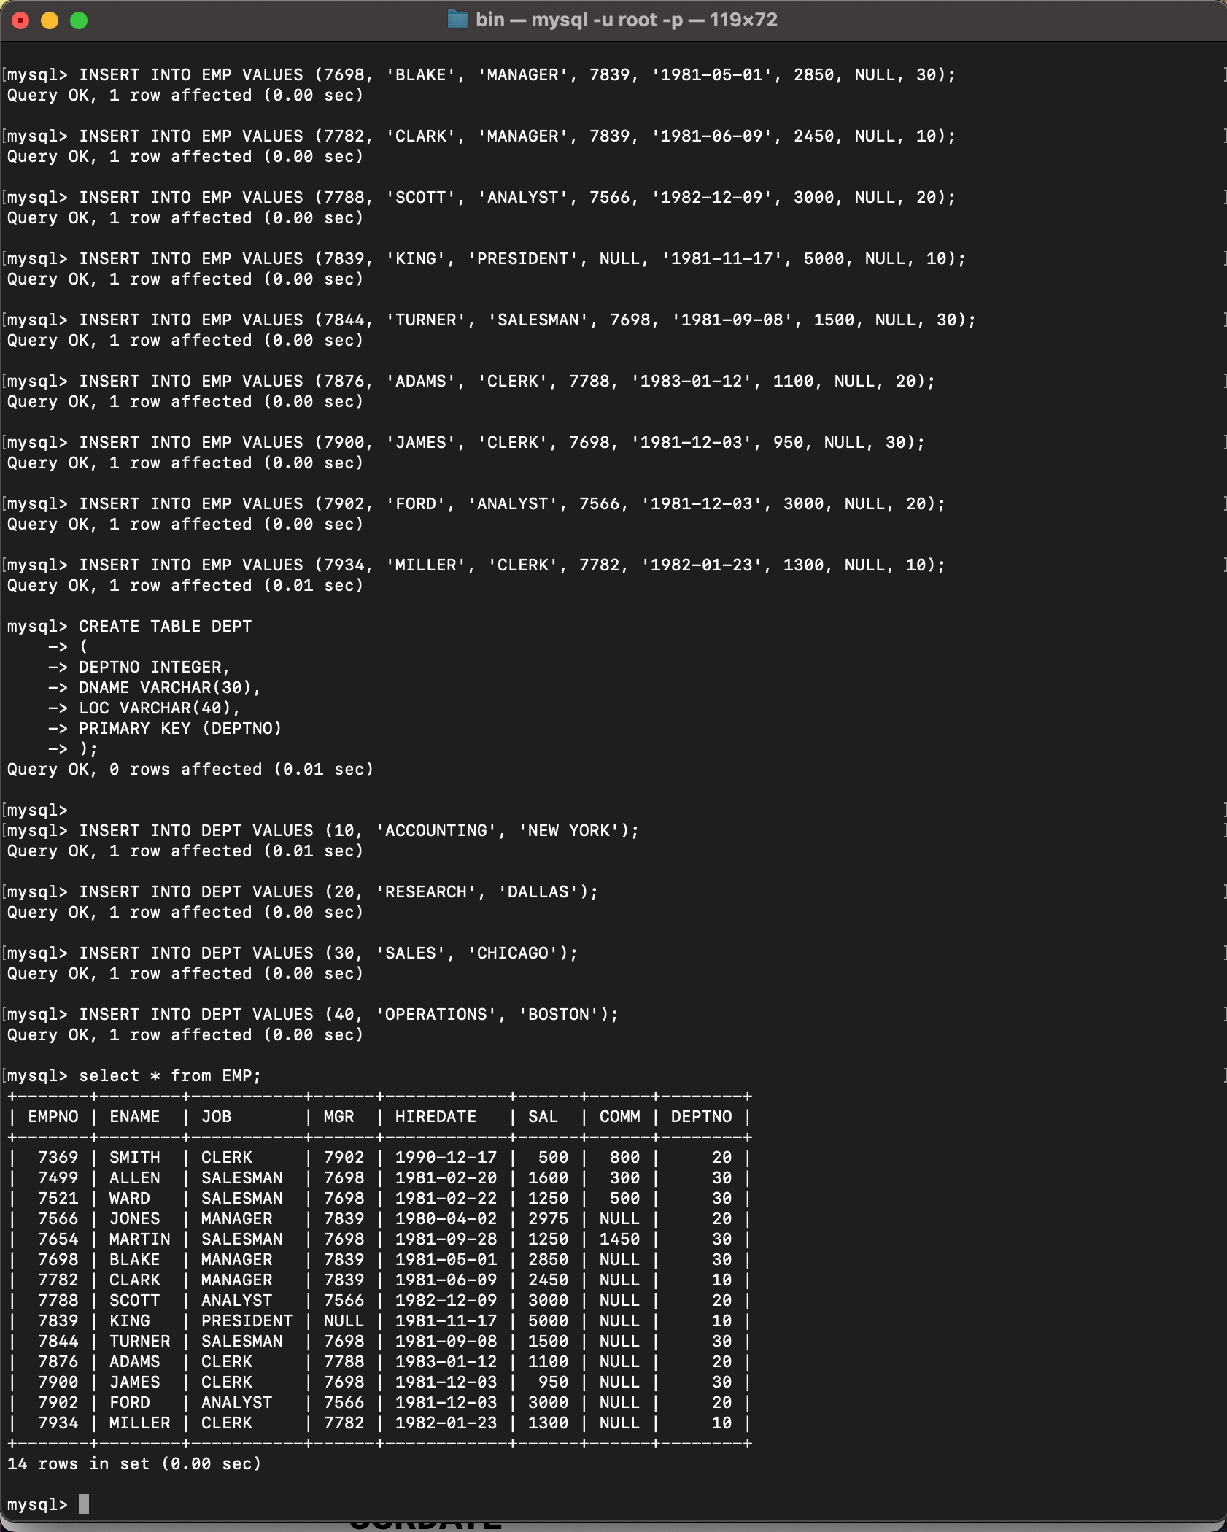

**DEPT TABLE**

DEPTNO DNAME LOC

---------- -------------- -------------

10 ACCOUNTING NEW YORK

20 RESEARCH DALLAS

30 SALES CHICAGO

40 OPERATIONS BOSTON

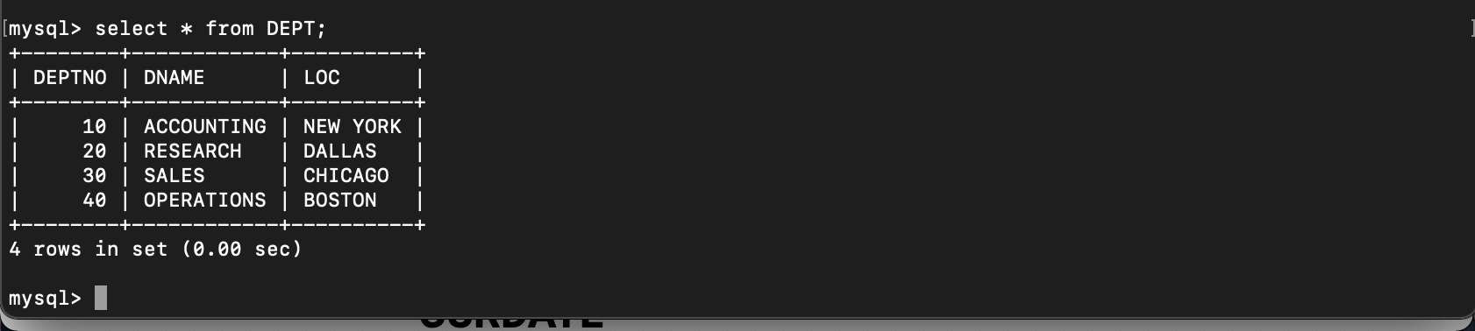

Write the Nested Queries for the following queries

1. List the details of the emps whose Salaries more than the employee BLAKE.

SELECT * FROM EMP WHERE SAL>(SELECT SAL FROM EMP WHERE ENAME = 'BLAKE');

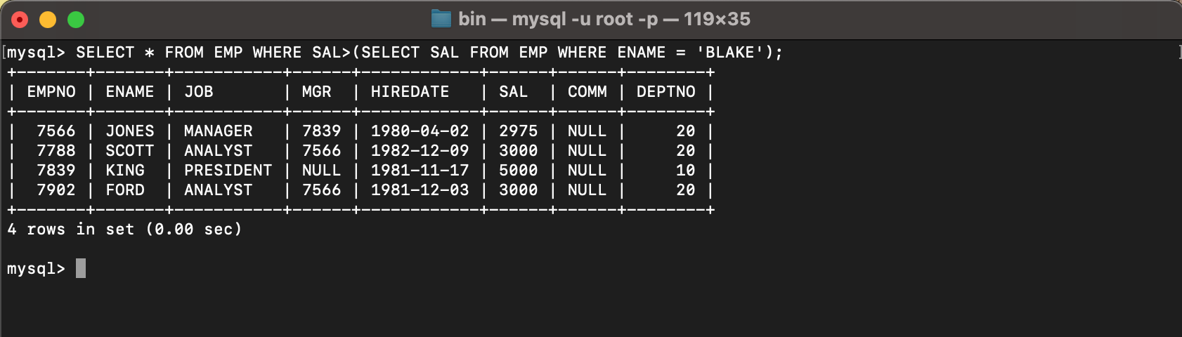

1. List the emps whose Jobs are same as ALLEN.

SELECT * FROM EMP WHERE JOB = (SELECT JOB FROM EMP WHERE ENAME = 'ALLEN');

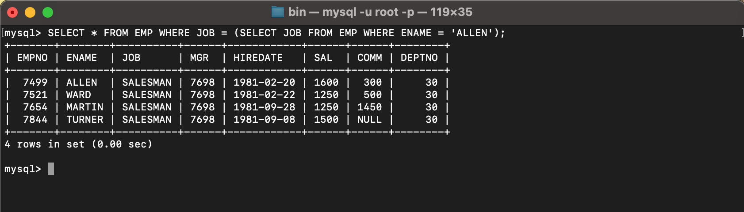

1. List the Emps whose Sal is same as FORD or SMITH in desc order of Names.

SELECT * FROM EMP WHERE SAL IN (SELECT SAL FROM EMP WHERE ENAME = 'FORD' OR ENAME = 'SMITH') ORDER BY ENAME DESC;

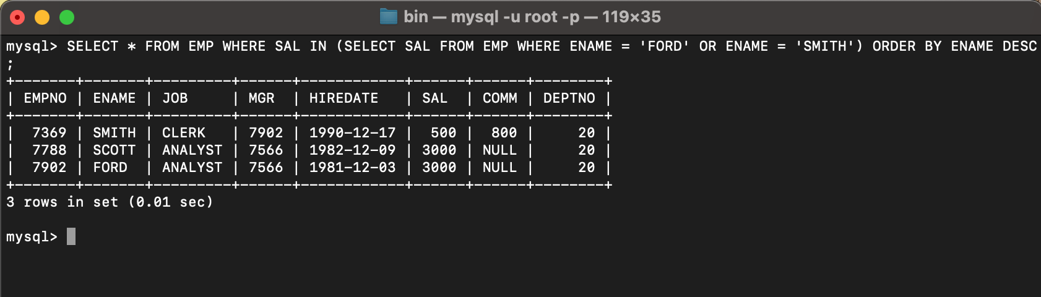

1. List the emps Whose Jobs are same as MILLER or Sal is more than ALLEN.

SELECT * FROM EMP WHERE JOB = (SELECT JOB FROM EMP WHERE ENAME = 'MILLER') OR SAL > (SELECT SAL FROM EMP WHERE ENAME = 'ALLEN');

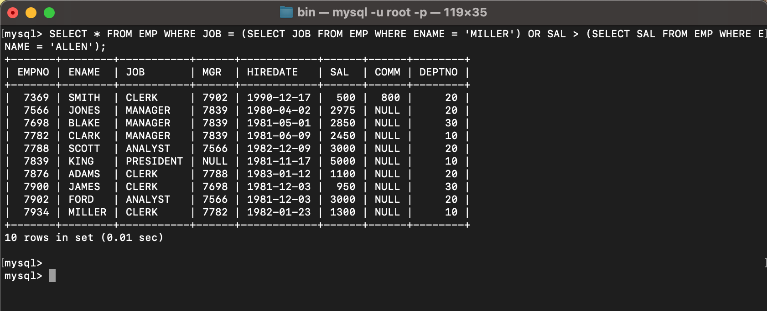

1. Find the highest paid employee of sales department.

SELECT ENAME FROM EMP WHERE SAL = (SELECT MAX(SAL) FROM EMP WHERE DEPTNO = (SELECT DEPTNO FROM DEPT WHERE DNAME = 'SALES'));

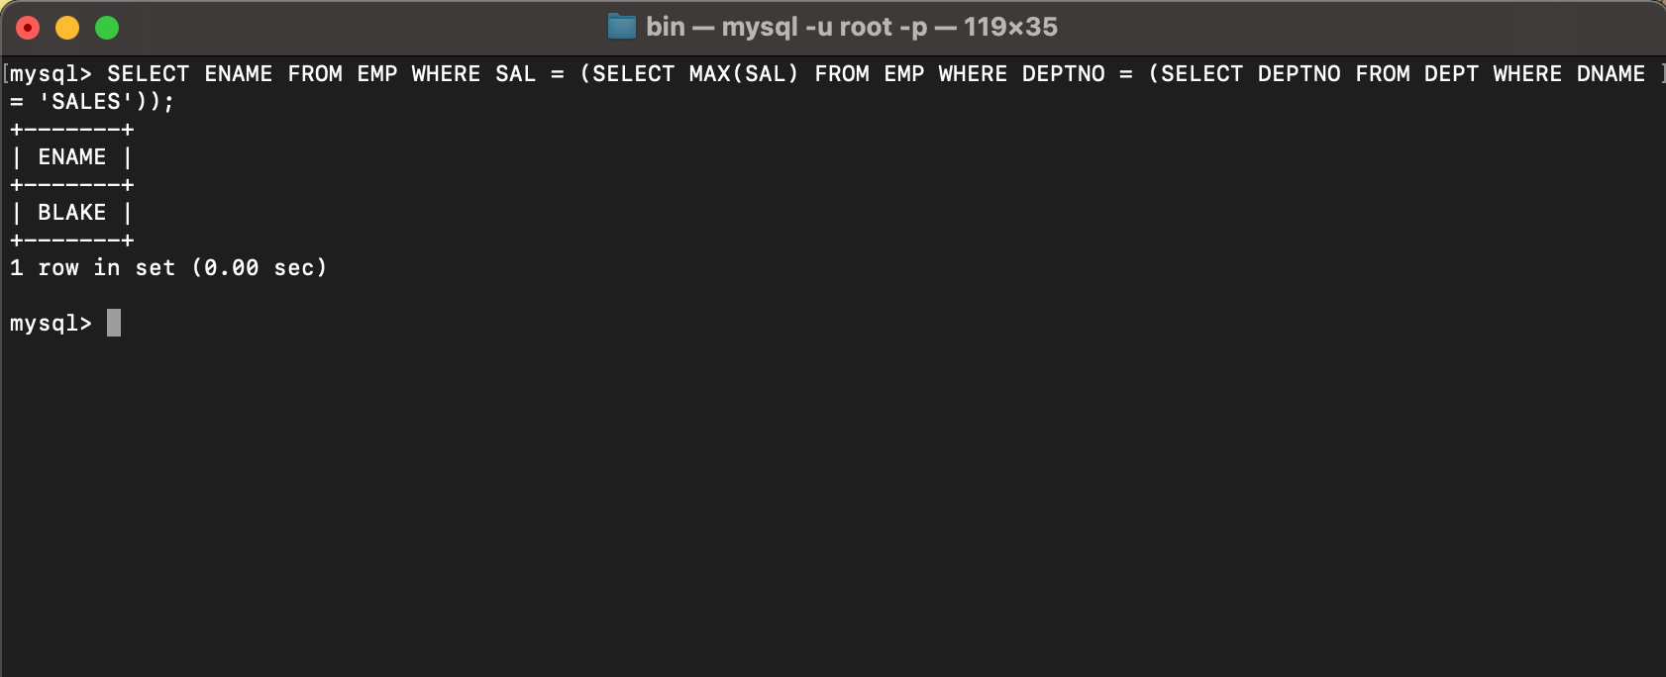

1. List the employees who are senior to most recently hired employee working under king.

SELECT ENAME FROM EMP WHERE HIREDATE < (SELECT MAX(HIREDATE) FROM EMP WHERE MGR IN (SELECT EMPNO FROM EMP WHERE ENAME = 'KING'));

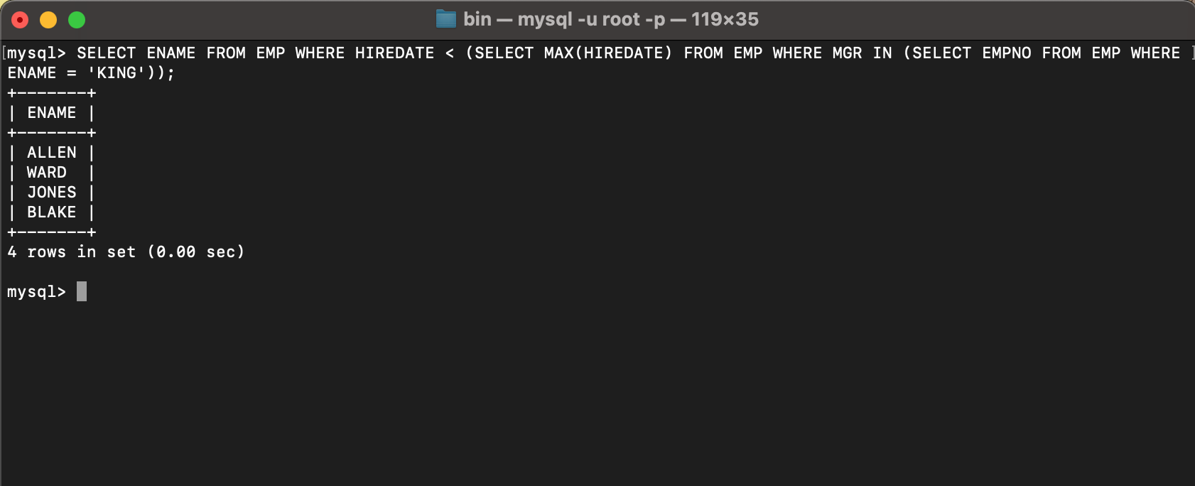

1. List the names of the emps who are getting the highest sal dept wise.

SELECT ENAME, DEPTNO FROM EMP WHERE SAL IN (SELECT MAX(SAL) FROM EMP GROUP BY DEPTNO);

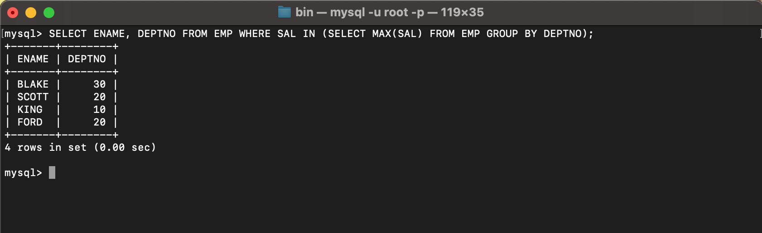

1. List the emps whose sal is equal to the average of max and minimum

SELECT ENAME FROM EMP WHERE SAL = (SELECT (MAX(SAL) + MIN(SAL))/2 FROM EMP);

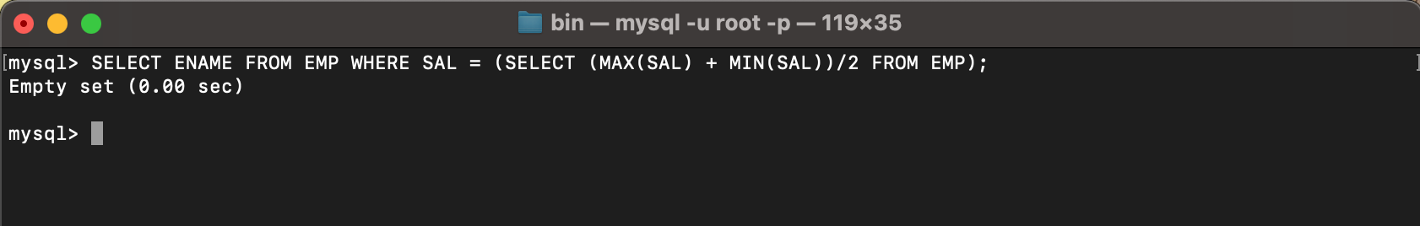

1. List the emps who joined in the company on the same date.

SELECT ENAME FROM EMP E WHERE HIREDATE IN (SELECT HIREDATE FROM EMP WHERE E.EMPNO <> EMPNO);

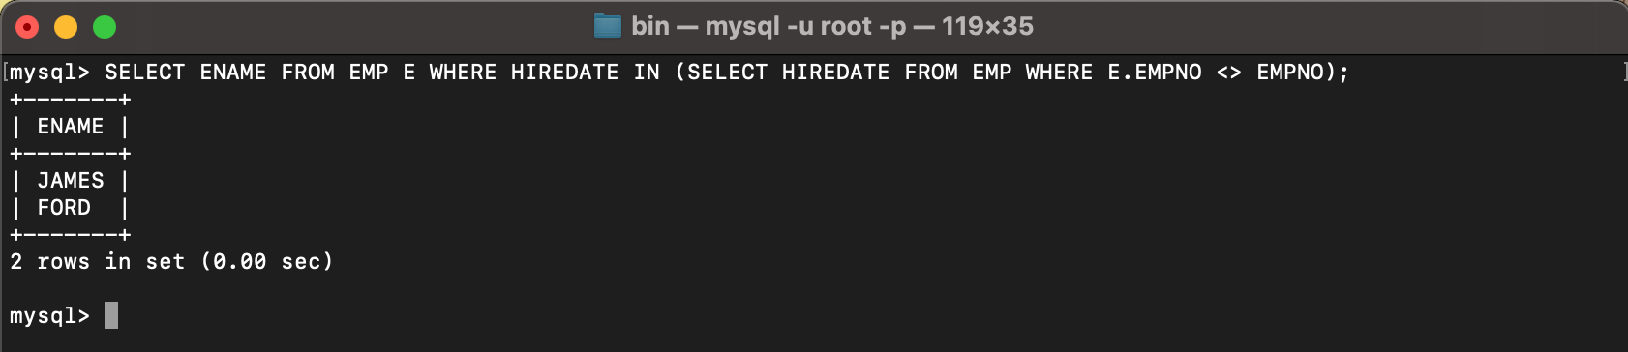

1. Find out the emps who joined in the company before their Managers.

SELECT ENAME FROM EMP E WHERE HIREDATE < (SELECT HIREDATE FROM EMP WHERE EMPNO = E.MGR);

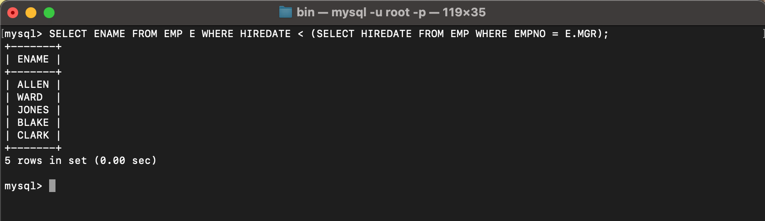

**LAB 5**

**EXPERIMENT-5**

**Title: 5. Use of different SQL clauses and join**

**Objective:** To understand the use of group by and having clause and execute the SQL commands using JOIN

**1. Write the SQL Queries for the following queries (use emp_table and dept_table of Experiment 4).**

1. List the Deptno where there are no emps.

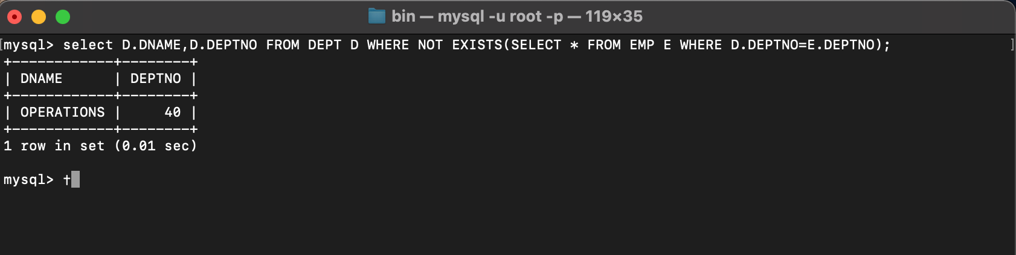

1. List the No.of emp’s and Avg salary within each department for each job.

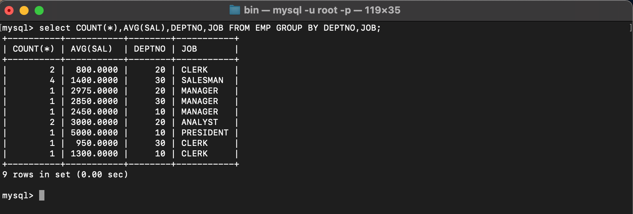

1. Find the maximum average salary drawn for each job except for ‘President’.

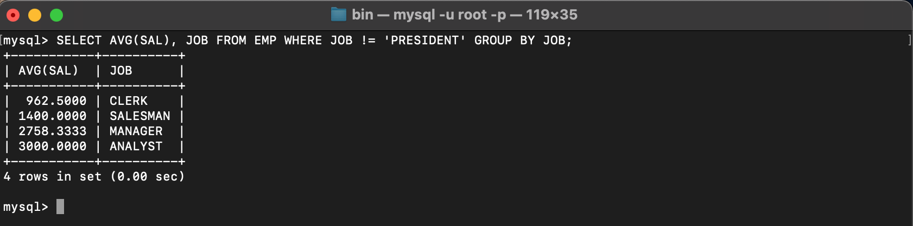

1. List the department details where at least two emps are working.

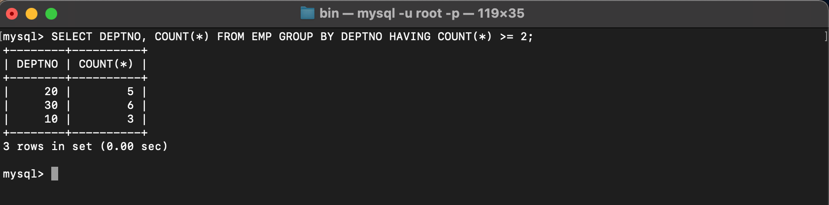

1. List the no. of emps in each department where the no. is more than 3.

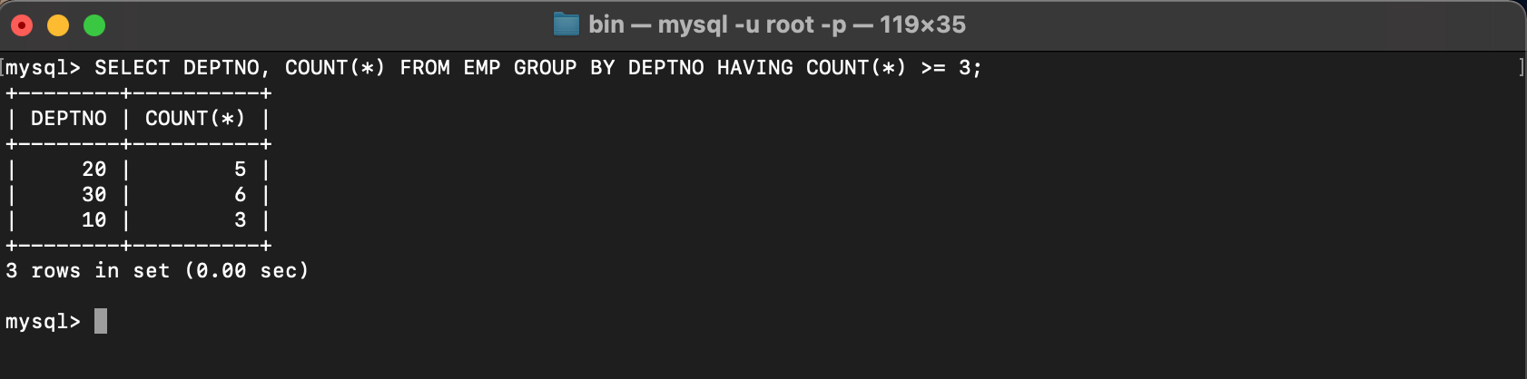

1. List the names of the emps who are getting the highest sal dept wise.

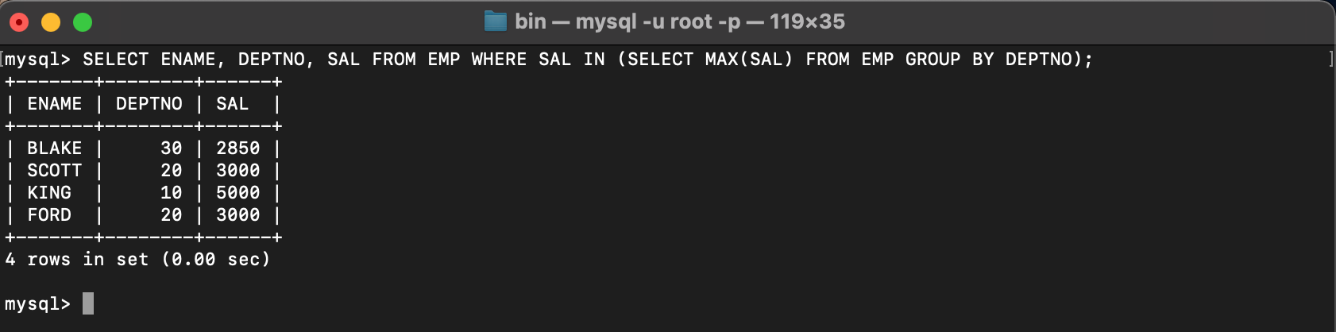

1. List the Deptno and their average salaries for dept with the average salary less than the averages for all departments.

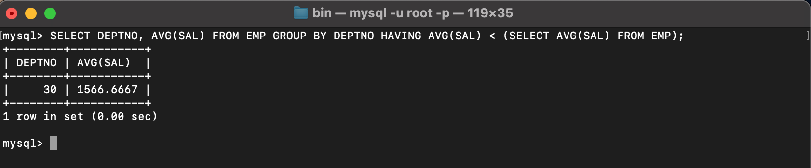

**2. Execute the experiment 4 using sql join.**

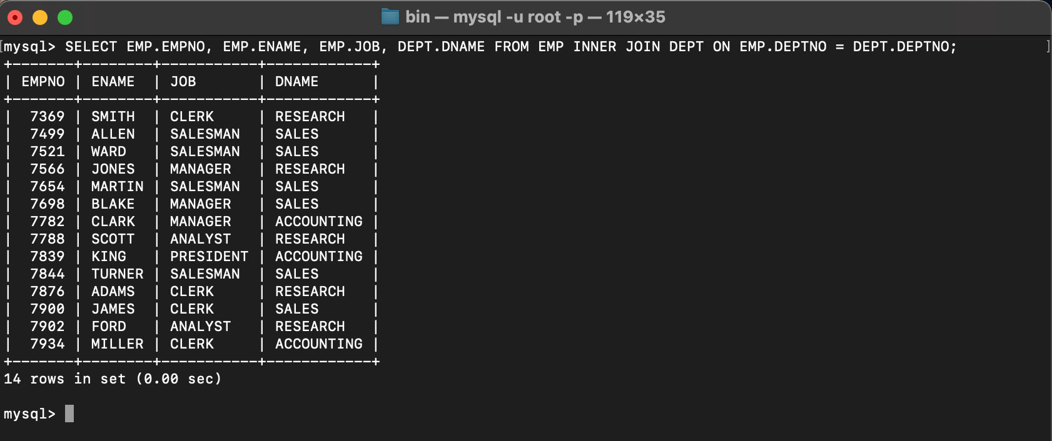

**LAB 6**

**EXPERIMENT-6**

**Title: 6. To understand the concepts of Views.  
Objective:** Students will be able to implement the concept of views.

**1. Create table of table name: EMPLOYEES and add 6 rows**

| Column Name | Data Type | Width | Attributes |
| --- | --- | --- | --- |
| Employee_id | Character | 10 | PK |
| First_Name | Character | 30 | NN |
| Last_Name | Character | 30 | NN |
| DOB | Date |  |  |
| Salary | Number | 25 | NN |
| Department_id | Character | 10 |  |

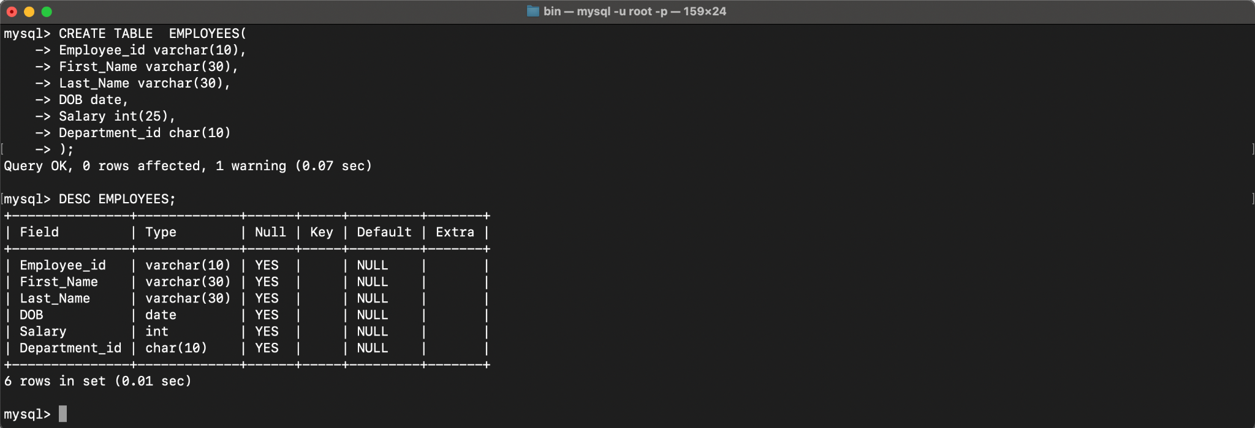

INSERT INTO EMPLOYEES VALUES ('7364','SMITH','MARK','1987-12-19','500','800');

INSERT INTO EMPLOYEES VALUES ('7365','JOHN','JOHN','1987-12-19','1500','802');

INSERT INTO EMPLOYEES VALUES ('7366','ROSS','GELLER','1987-12-19','5020','803');

INSERT INTO EMPLOYEES VALUES ('7367','MONICA','GELLER','1987-12-19','5500','804');

INSERT INTO EMPLOYEES VALUES ('7368','SMITH','CLERK','1987-12-19','5000','805');

INSERT INTO EMPLOYEES VALUES ('7369','RACHEL','GREEN','1987-12-19','10500','806');

SELECT * FROM EMPLOYEES;

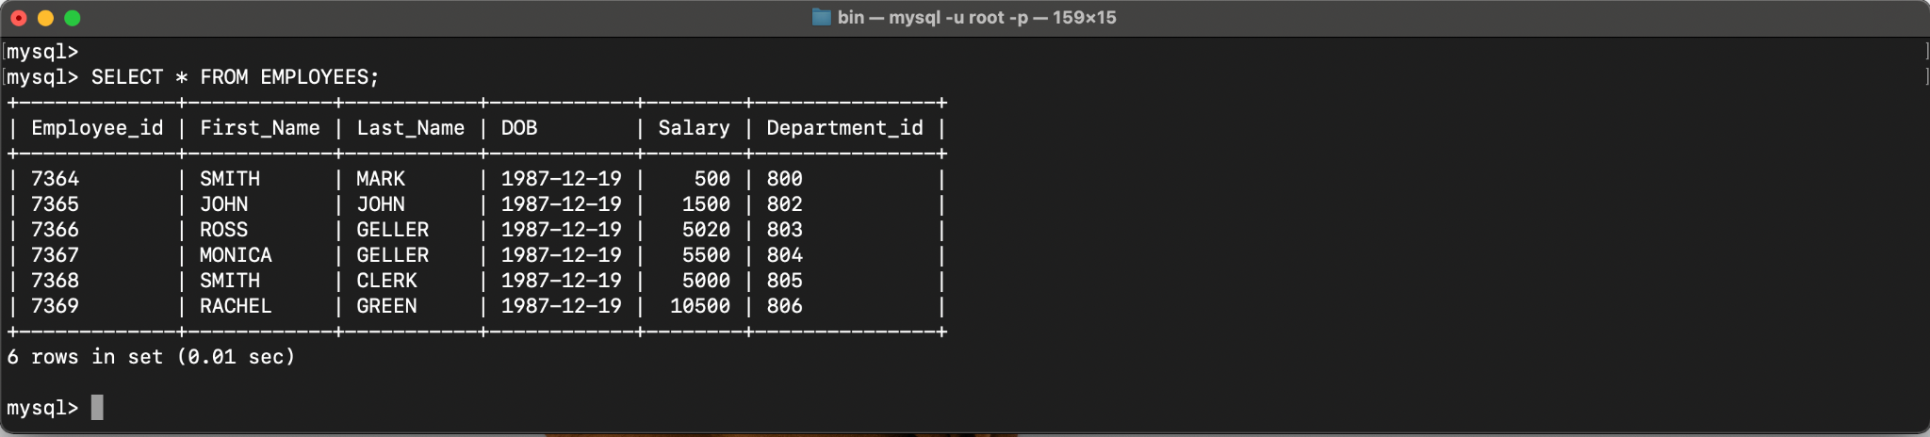

**2. Execute the following view related queries:**

1) Create View of name emp_view and the column would be Employee_id, Last_Name, salary and department_id only.:

CREATE VIEW emp_view AS SELECT Employee_id, Last_Name, salary, department_id FROM EMPLOYEES;

2) Insert values into view(remove the NOT NULL constraint and then insert values):

INSERT INTO emp_view VALUES ('7364','MARK','500','800');

INSERT INTO emp_view VALUES ('7365','JOHN','1500','802');

INSERT INTO emp_view VALUES ('7366','GELLER','5020','803');

INSERT INTO emp_view VALUES ('7367','GELLER','5500','804');

INSERT INTO emp_view VALUES ('7368','CLERK','5000','805');

INSERT INTO emp_view VALUES ('7369','GREEN','10500','806');

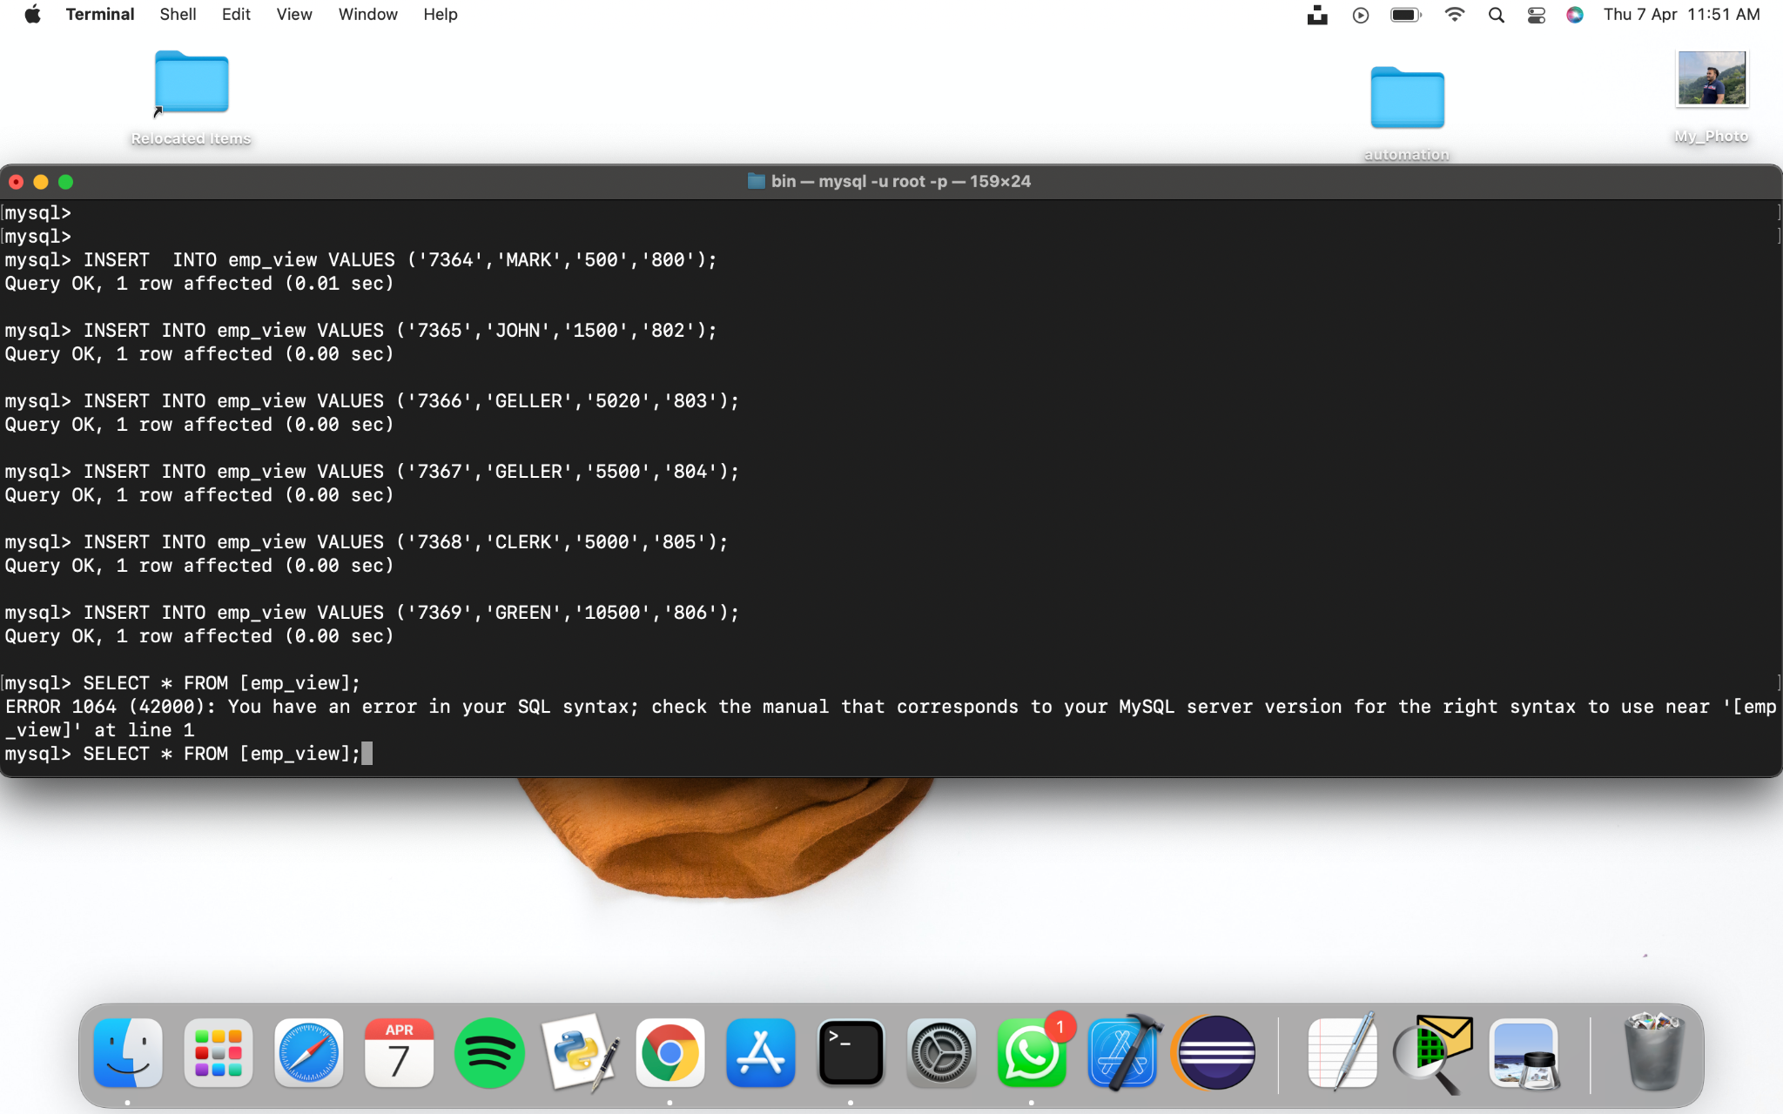

3) Modify, delete and drop operations are performed on view.:

CREATE OR REPLACE VIEW contacts AS SELECT Employee_id, Last_Name FROM emp_view;

DROP VIEW salary_view;

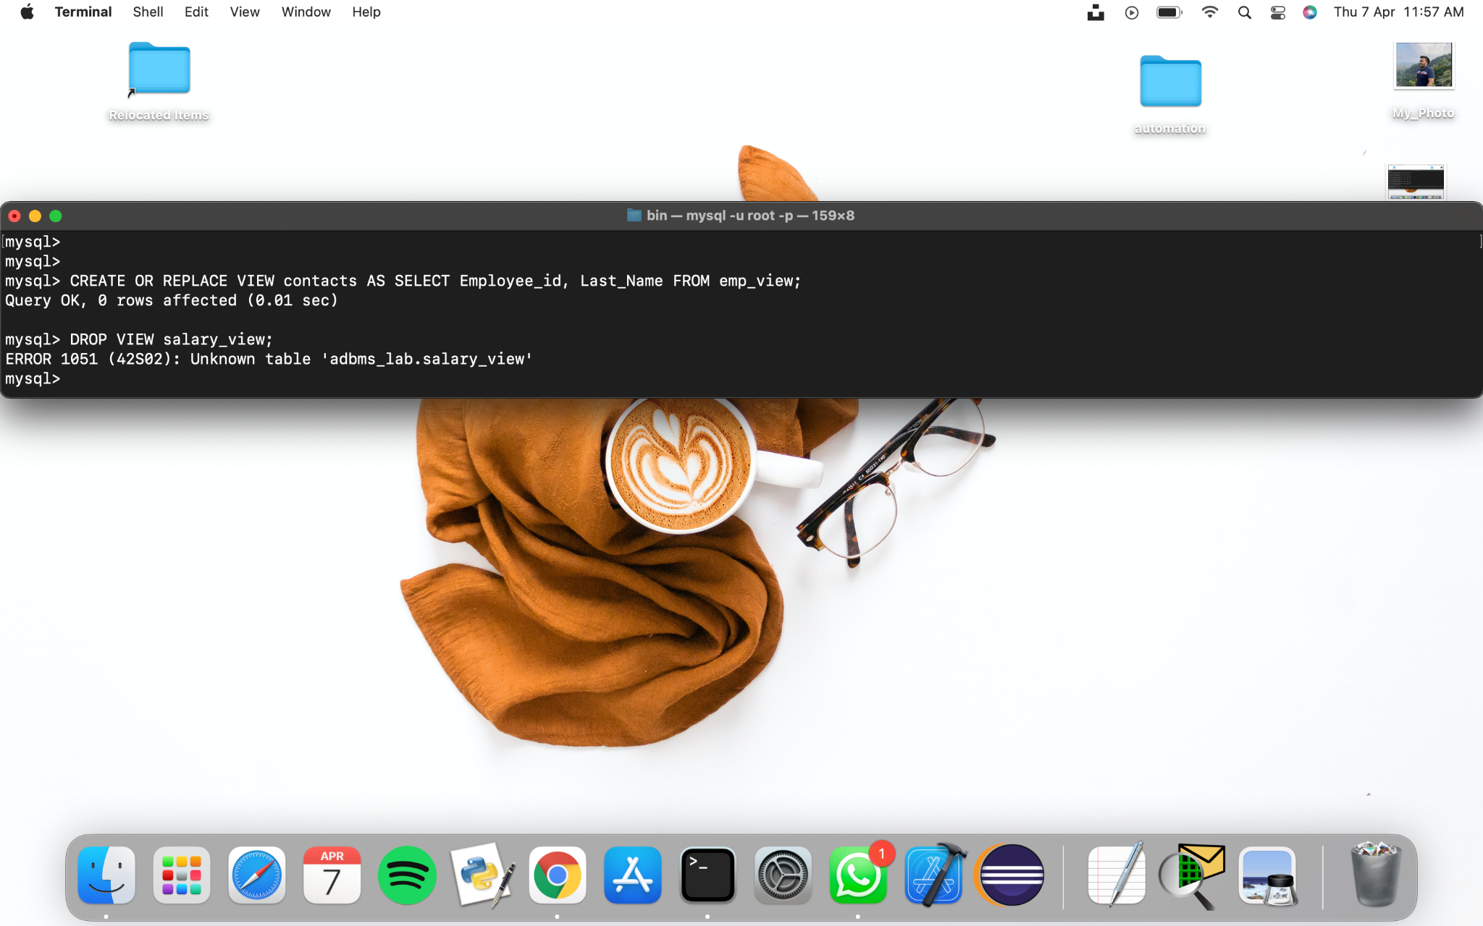

4) Creates a view named salary_view. The view shows the employees in department 20 and their annual salary.

CREATE VIEW salary_view AS SELECT salary, department_id FROM emp_view where department_id = 800;

SELECT * FROM emp_view;

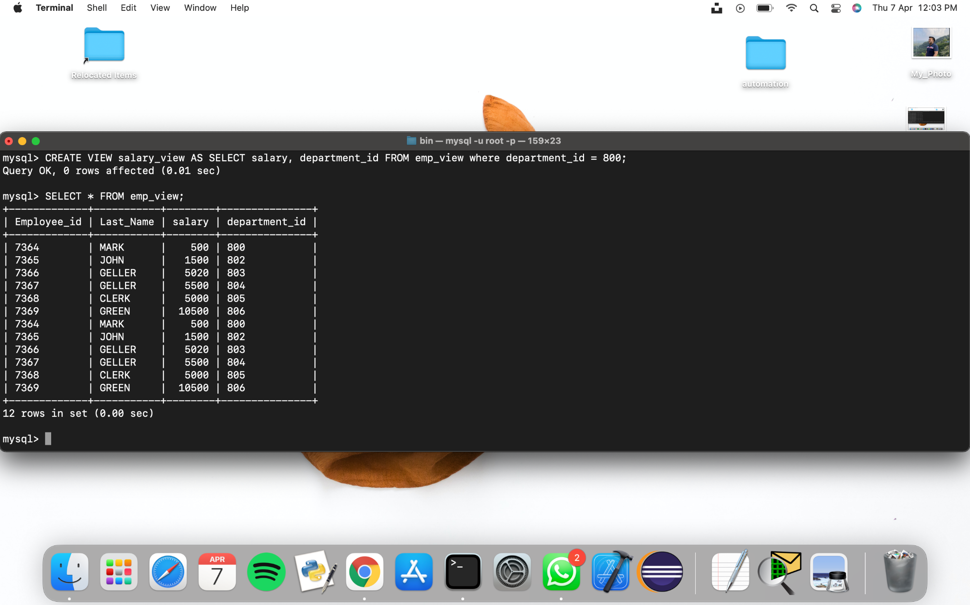

**LAB 7**

**EXPERIMENT-7**

**Title: 7. To understand the concepts of Index.   
Objective:** Students will be able to implement the concept of index.

**1. Execute the following index related queries:**

1) Create an index of name employee_idx on EMPLOYEES with column Last_Name, Department_id

CREATE INDEX EMPLOYEE_IDX ON EMPLOYEES (LAST_NAME, DEPARTMENT_ID);

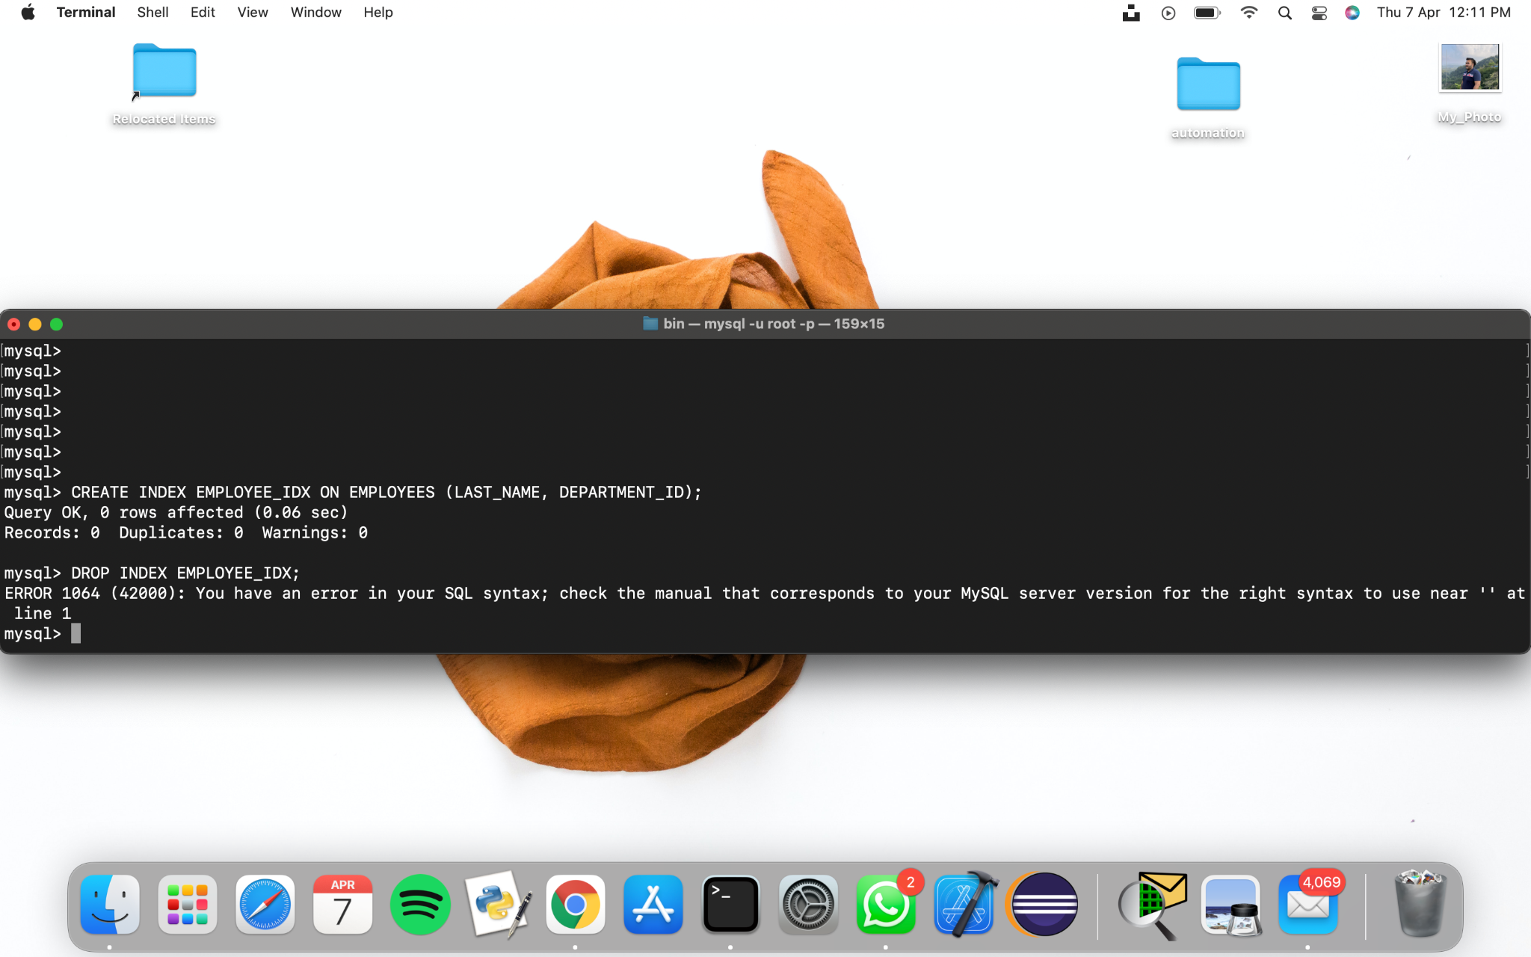

**2) Find the ROWID for the above table and create a unique index on employee_id column of the EMPLOYEES.**

SELECT ROW_NUMBER() OVER(ORDER BY DEPARTMENT_ID) AS ID, EMPLOYEE_ID, FIRST_NAME, LAST_NAME, DEPARTMENT_ID FROM EMPLOYEES;

CREATE UNIQUE INDEX EMPLOYEE_UNI_IDX ON EMPLOYEES (EMPLOYEE_ID);

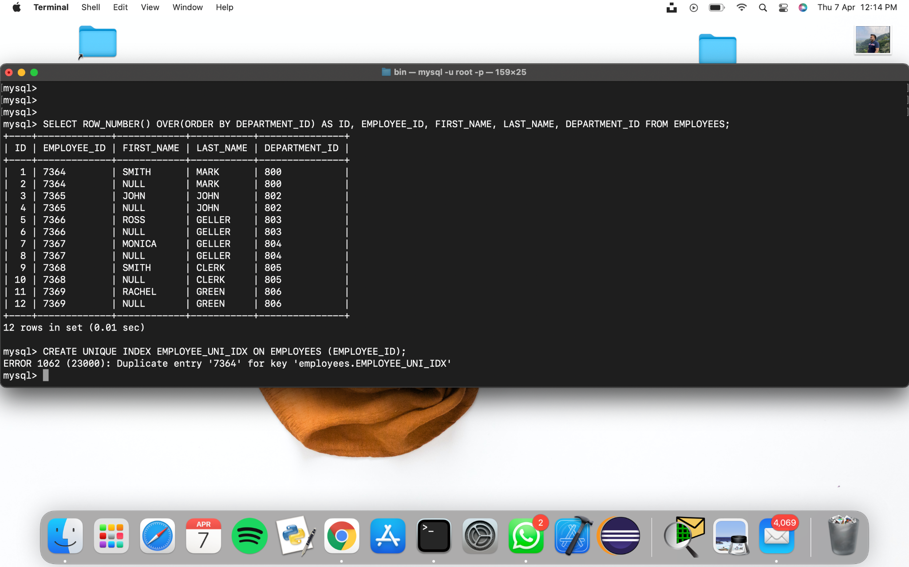

**3) Create a reverse index on employee_id column of the EMPLOYEES.**

CREATE INDEX EMP_REVERSE ON EMPLOYEES (EMPLOYEE_ID) REVERSE;

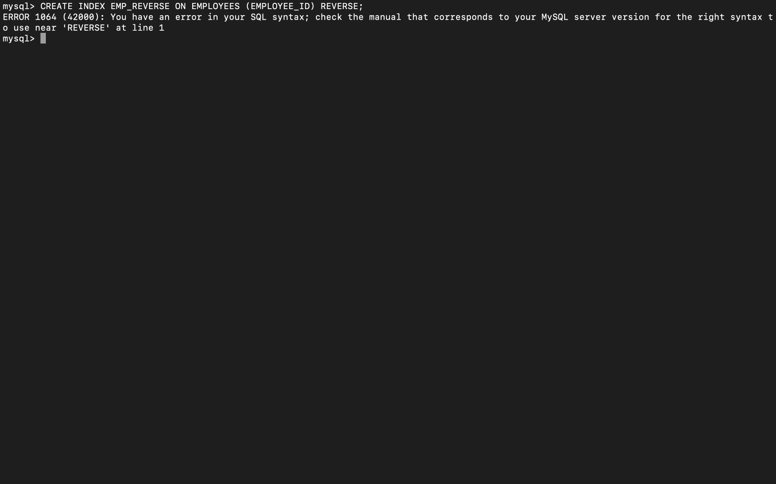

**4) Create a unique and composite index on employee_id and check whether there is duplicity of tuples or not.**

CREATE UNIQUE INDEX EMPLOYEE_UNI_COMP ON EMPLOYEES (EMPLOYEE_ID, DEPARTMENT_ID);

SELECT * FROM EMPLOYEES WHERE EMPLOYEE_ID = 'E1' AND DEPARTMENT_ID = 'DP4';



**5) Create Function-based indexes defined on the SQL functions UPPER(column_name) or LOWER(column_name) to facilitate case-insensitive searches(on column Last_Name).**

CREATE INDEX LAST_NAME_IDX ON EMPLOYEES (UPPER(LAST_NAME));

CREATE INDEX LAST_NAME_IDX2 ON EMPLOYEES (lower(LAST_NAME));



**6) Drop the function based index on column Last_Name.**

DROP INDEX LAST_NAME_IDX;

DROP INDEX LAST_NAME_IDX2;



**LAB 8**

**EXPERIMENT-8**

**Title: 8. To understand the concepts of Sequence.**

**Objective:** Students will be able to implement the concept of sequence.

1) Create a sequence by name EMPID_SEQ starting with value 100 with an interval of 1.

**CREATE SEQUENCE EMPID_SEQ**

**START WITH 100**

**INCREMENT BY 1**

**MINVALUE 100**

**MAXVALUE 200**

**CYCLE;**

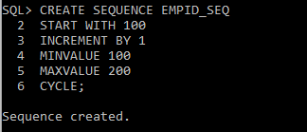

2) Write a SQL command for finding the current and the next status of EMPID_SEQ.

**SELECT EMPID_SEQ.NEXTVAL FROM EMP;**

**SELECT EMPID_SEQ.CURRVAL FROM EMP;**

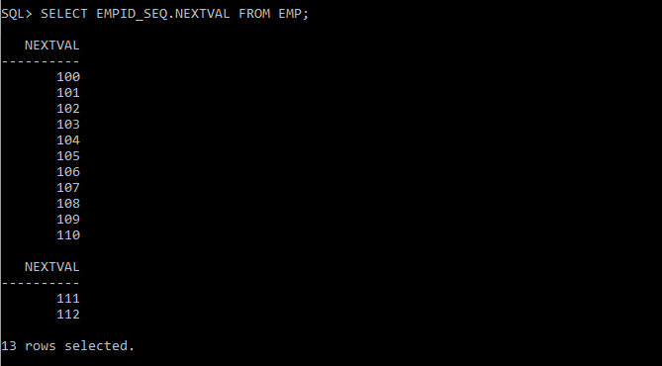

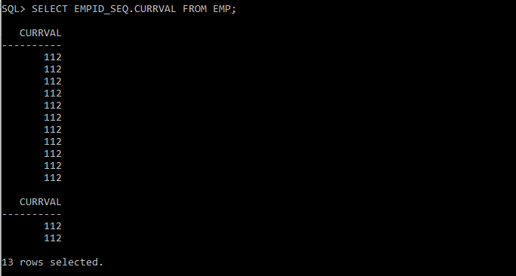

3) Change the Cache value of the sequence EMPID_SEQ to 20 and maxvalue to 1000.

**ALTER SEQUENCE EMPID_SEQ**

**MAXVALUE 1000**

**CACHE 20;**

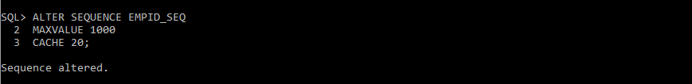

4) Insert values in employees table using sequences for employee_id column.

**INSERT INTO EMP VALUES (EMPID_SEQ.NEXTVAL, 'DEVASHISH', 'BOSS', '8000', '16-NOV-99', '6000', '4000', '10');**

**SELECT * FROM EMP;**

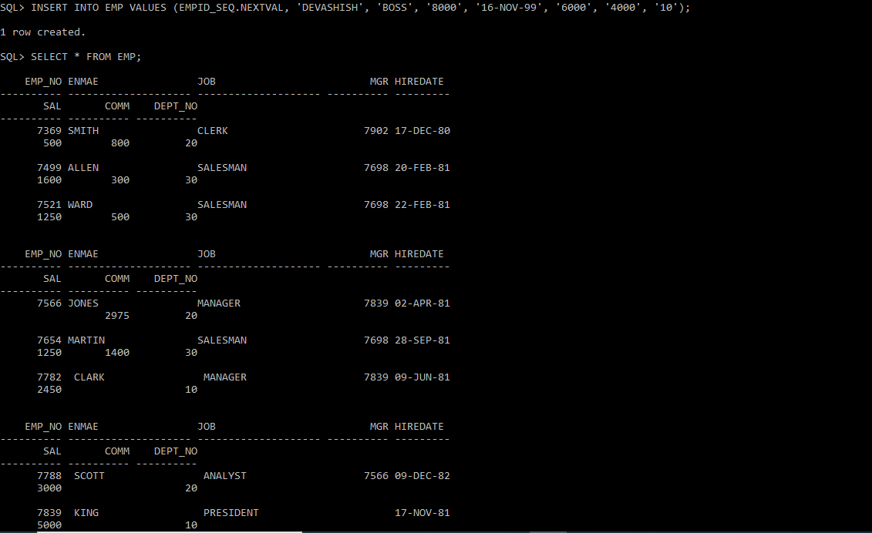

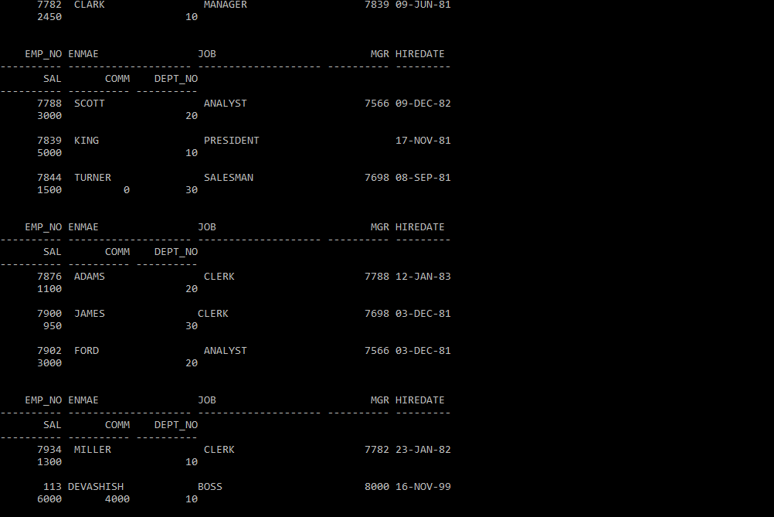

5) Drop sequence EMPID_SEQ.

**DROP SEQUENCE EMPID_SEQ;**

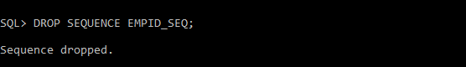

6) Create a sequence called REVERSE to generate numbers in the descending order from 10000 to 1000 with a decrement of 5.

**CREATE SEQUENCE REVERSE**

**START WITH 10000**

**INCREMENT BY -5**

**MINVALUE 1000**

**MAXVALUE 10000**

**CYCLE**

**CACHE 3;**

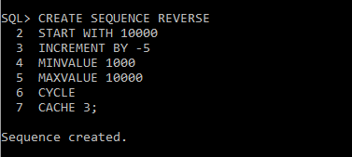

**LAB 9**

**EXPERIMENT-9**

**Title: To understand the concepts of PL/SQL programming.**

**Objective: Students will be able to implement the basic concepts of Pl/SQL.**

1. **Write a PL/SQL code to accept the value of A, B & C display which is greater.**

DECLARE

a NUMBER := 40;

b NUMBER := 60;

c NUMBER := 80;

BEGIN

IF a > b

AND a > c THEN

dbms_output.Put_line('Greatest number is '||a);

ELSIF b > a

AND b > c THEN

dbms_output.Put_line('Greatest number is '||b);

ELSE

dbms_output.Put_line('Greatest number is '||c);

END IF;

END;

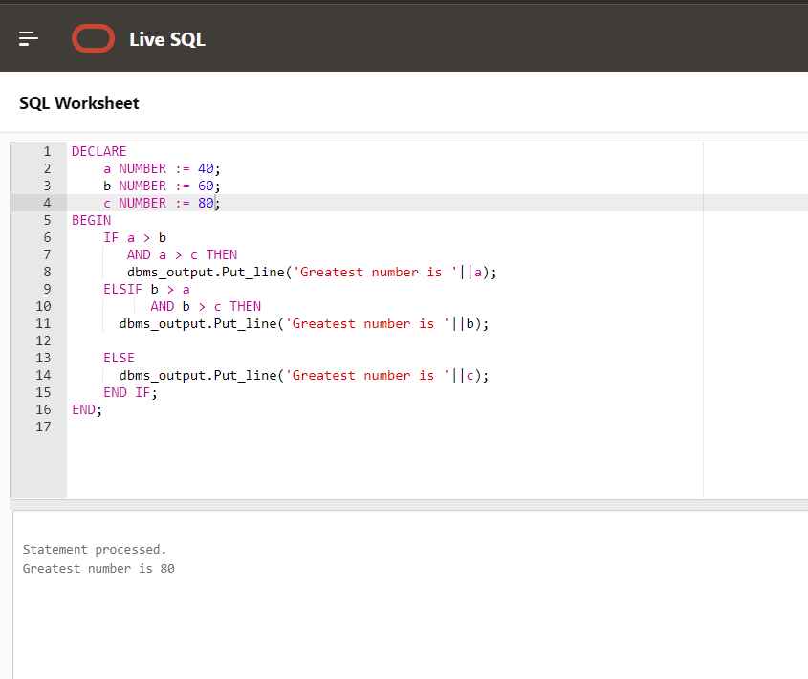

1. **Using PL/SQL Statements create a simple loop that display message “Welcome to PL/SQL Programming” 20 times.**

Code

Declare

a number := 20;

begin

for a in 1 .. 20 loop

dbms_output.put_line('Welcome to PL/SQL Programming');

end loop ;

END;

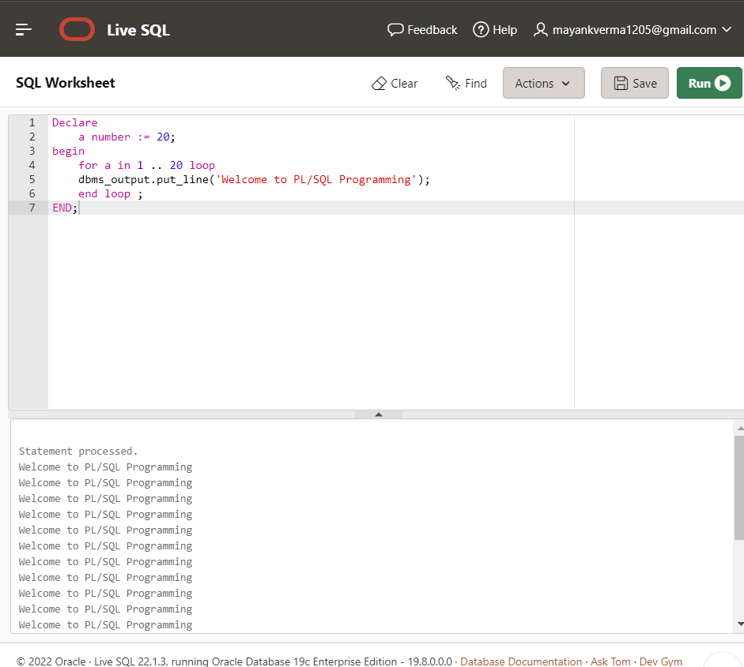

1. **Write a PL/SQL code block to find the factorial of a number.**

Declare

a number := 20;

b number := 10;

begin

for i in 1..a loop

b := b*1;

end loop;

dbms_output.put_line('Fctorial of a is' ||b );

END;

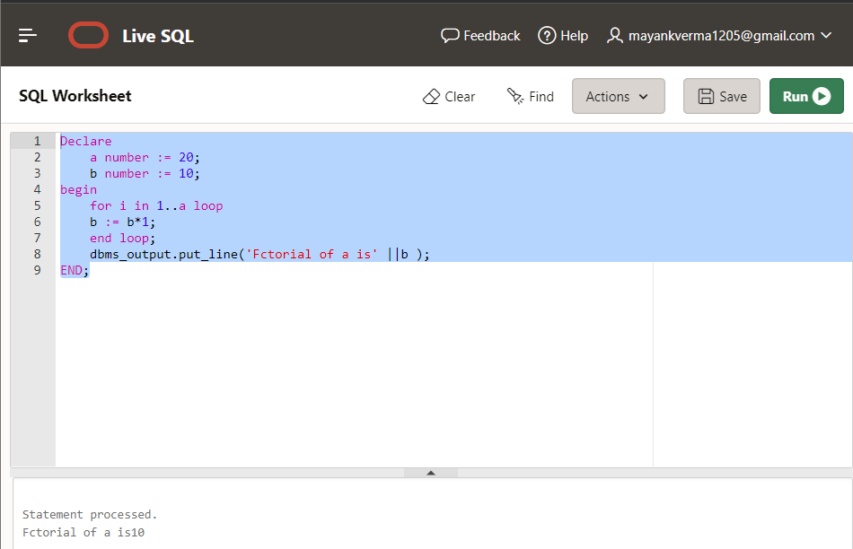

1. **Write a PL/SQL program to generate Fibonacci series.**

Declare

n number := 20;

f0 number := 0;

f1 number :=10;

fib number;

BEGIN

dbms_output.put_line('the Fibonacci series is' );

for i in 1..n loop

fib := f0 + f1;

f0 := f1 ;

f1 := fib;

dbms_output.put_line( fib );

end loop;

END;

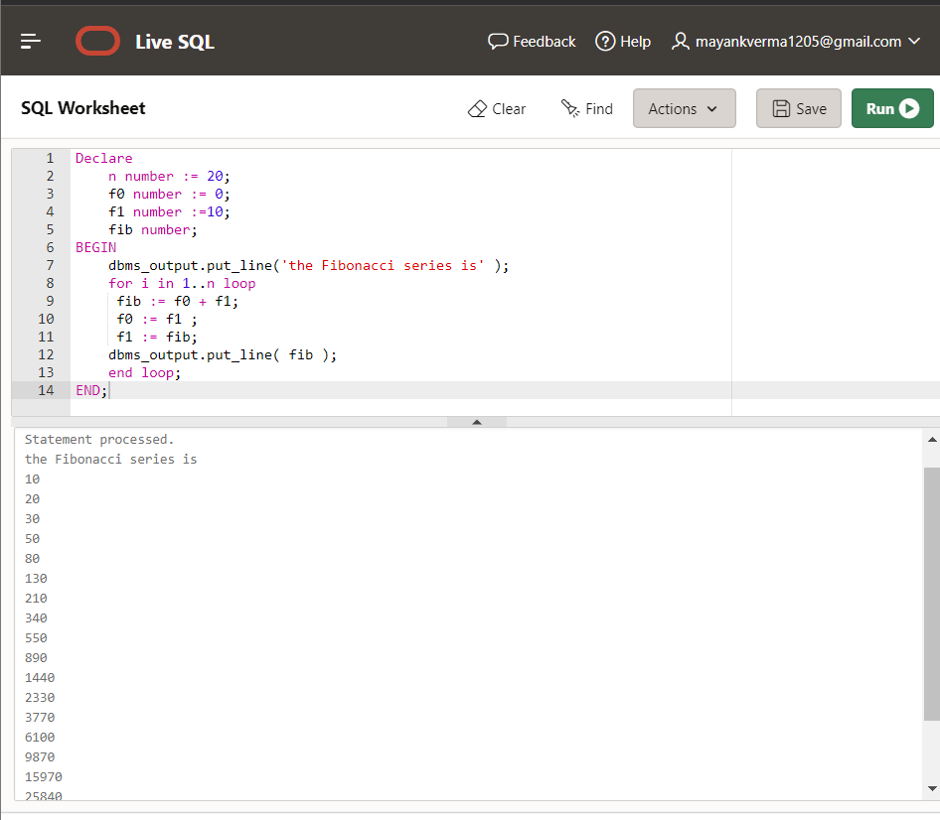

1. **Write a PL/SQL code to fund the sum of first N number**

Declare

a number := 200;

b number := 0;

BEGIN

for i in 1..a loop

b := b+i ;

end loop ;

dbms_output.put_line( 'The sum of first N number is' || b );

END;

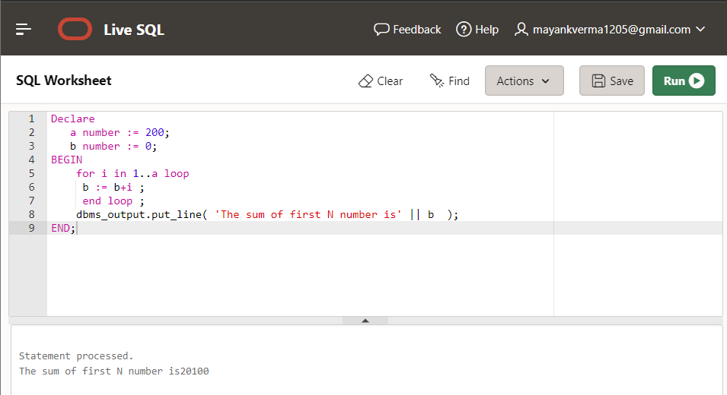

**LAB 10**

**EXPERIMENT-10**

**Title: 10. To understand the concepts of function and procedure in PL/SQL.**

Objective: Students will be able to implement the Pl/SQL programs using function and procedure.

**1) Write a PL/SQL code to accept the value of A, B & C display which is greater**.

DECLARE

x number: = 12;

y number: = 18;

z number: = 24;

maximum number;

FUNCTION find_max (x IN number, y IN number, z IN number)

RETURN number

IS

largest number;

BEGIN

if x>y and x>z then

largest: = x;

else

if y>x and y>z then

largest: = y;

else

largest: = z;

end if;

end if;

RETURN largest;

END;

begin

dbms_output.put_line ('X = '||x||', Y = '||y||', Z = '||z);

maximum: = find_max (12, 18, 24);

IF maximum = x then

dbms_output.put_line ('X is the greatest');

end if;

if maximum = y then

dbms_output.put_line ('Y is the greatest');

end if;

if maximum = z then

dbms_output.put_line ('Z is the greatest');

end if;

end;

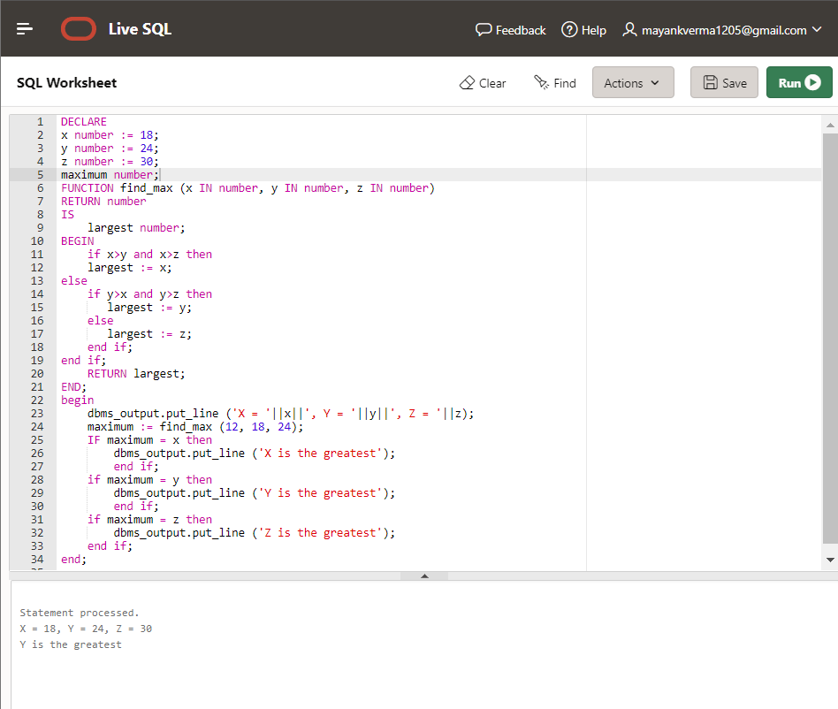

**2) Using PL/SQL Statements create a simple loop that display message “Welcome to PL/SQL Programming” 20 times.**

DECLARE

counter number: =1;

FUNCTION Print (count IN number)

RETURN number

IS

c number;

BEGIN

c: = 1;

WHILE c <= 20

LOOP

dbms_output.put_line (c || ' Welcome to PL/SQL Programming');

c: = c+1;

END LOOP;

RETURN c;

END;

BEGIN

counter: = Print(counter);

END;

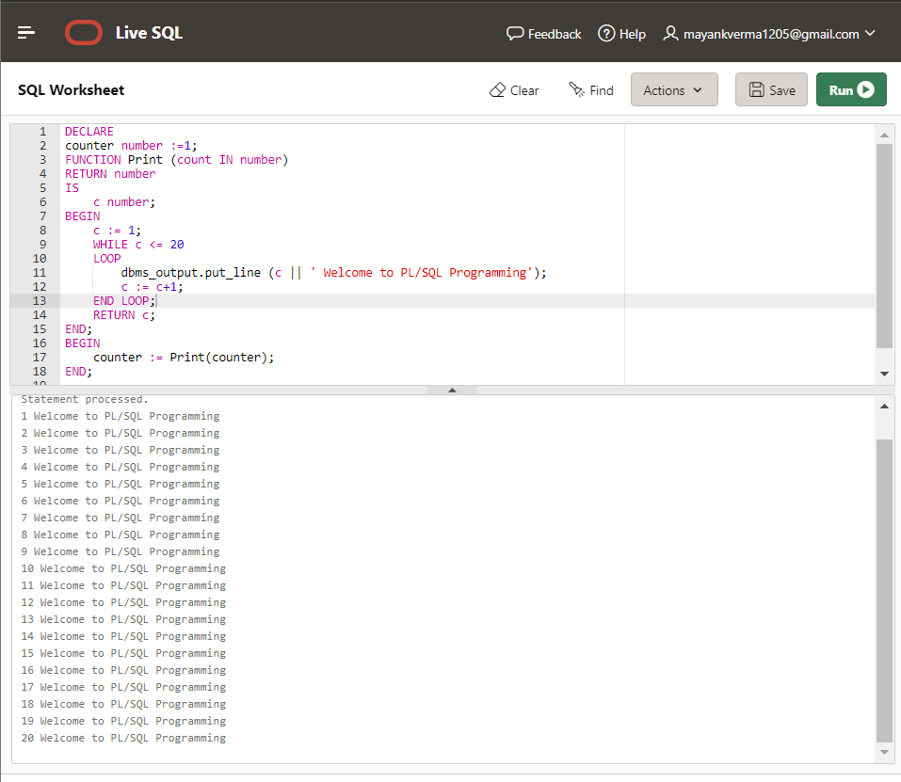

**3) Write a PL/SQL code block to find the factorial of a number.**

DECLARE

x number;

factorial_store number;

FUNCTION find_factorial (x number)

RETURN number

IS

fact number;

BEGIN

IF x = 0 THEN

fact: = 1;

ELSE

fact: = x * find_factorial(x-1);

END IF;

RETURN fact;

END;

BEGIN

x: = 10;

factorial_store: = find_factorial(x);

dbms_output.put_line (' Factorial of '|| x || ' is ' || factorial_store);

END;

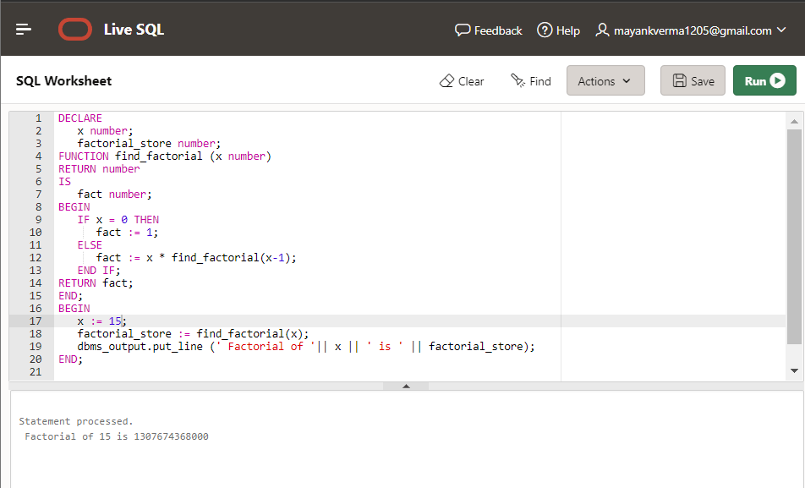

**4) Write a PL/SQL program to generate Fibonacci series**

DECLARE

x number: = 0;

y number: = 1;

z number: = 0;

initialize number: = 1;

n number: = 10;

temp_store number;

temp_return number: =0;

FUNCTION Fibonacci_Generator (first_term IN OUT number, second_term IN OUT number, add_counter IN OUT number, count_var IN OUT number, limithead IN OUT number)

RETURN number

IS

temp_return number;

BEGIN

while count_var <= limithead

loop

dbms_output.put_line (first_term || ' ');

add_counter: = second_term;

second_term: = first_term + second_term;

first_term: = add_counter;

count_var: = count_var+1;

END LOOP;

RETURN temp_return;

END;

BEGIN

temp_store: = Fibonacci_Generator (x, y, z, initialize, n);

END;

Output

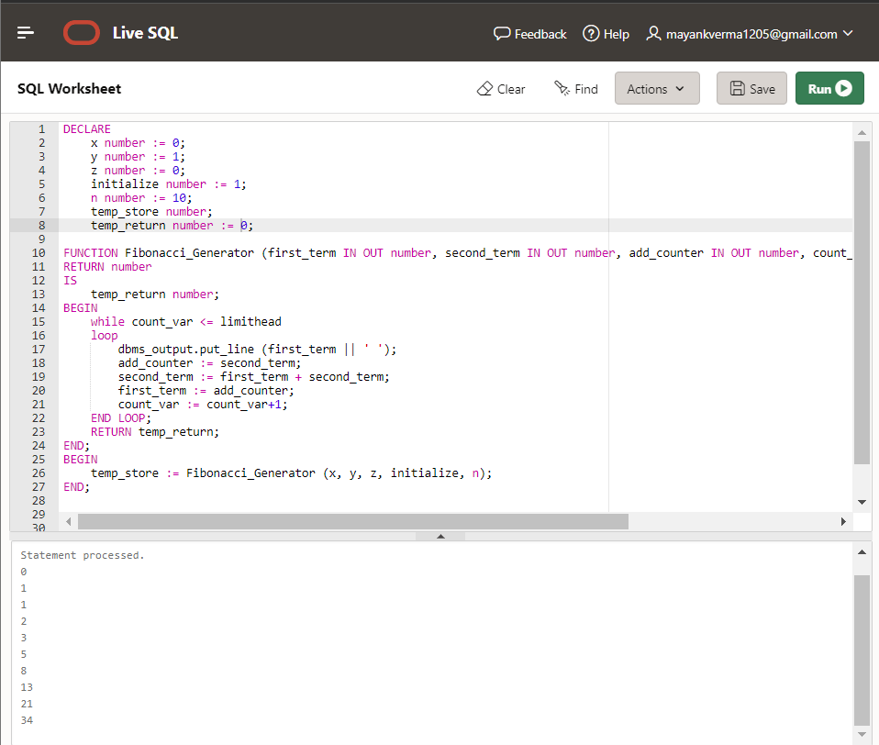

**5) Write a PL/SQL code to fund the sum of first N numbers**

DECLARE

x NUMBER;

n NUMBER;

i NUMBER;

FUNCTION find_sum (n IN NUMBER)

RETURN NUMBER

IS

summation NUMBER: = 0;

BEGIN

FOR i IN 1...n

LOOP

summation: = i*(i+1)/2;

END LOOP;

RETURN summation;

END;

BEGIN

n: = 10;

x: = find_sum(n);

dbms_output.put_line('Sum of first 10 numbers is: ' || x);

END;

